1. DCCA ARCHITECTURAL GUIDELINES OVERVIEW 4
2. LEGAL DOCUMENTS 5
A. Covenants 5
B. General Property Covenants 5
3. ARCHITECTURAL REVIEW PROCESS 6
4. BUILDING PERMIT and CODES 8
A. Impervious Surface 8
B. North Carolina One Call Center 8
5. DCCA COMMON AREA RESTRICTIONS 8
6. ALARM SYSTEMS and SECURITY CAMERAS (*AMA not required) 9
7. ANTENNA -Covered by Special FCC Rules c 9
8. ANTENNAS –NOT Covered by Special FCC Rules 10
9. ARBORS 10
10. AWNINGS 10
11. CARPORTS 10
12. CLOTHES LINES (*AMA not required) 10
13. COMPOSTERS: (*AMA not required) 10
14. DECKS 11
A. General Deck Application requirements: 11
B. New Decks or Modifications to Existing Decks 11
C. Materials 12
D. Deck Preserving and Staining 12
E. Repair or Maintenance of Existing Decks 12
15. DOG HOUSES/RUNS 13
16. EXTERIOR LIGHTING (*AMA not required) 13
17. FIRE PITS/BARBEQUES-BUILT IN 14
18. FREESTANDING STRUCTURES 14
A. Sheds 14
19. EXTERIOR ADDITIONS 14
A. Addition Application requirements 15
B. Appearance 15
20. EXTERIOR ALTERATIONS or MODIFICATIONS 16
21. FENCING 16
A. Fence Application requirements 16
B. General Fence Guidelines 17
C. Fence Styles 17
D. Wooden picket style fences 19
E. Illustrative Site Plan 20
22. FLAGS, US (*AMA not required) 21
23. GENERAL COMMUNITY CONSIDERATIONS 21
A. Pets 21
B. Parking 21
24. GENERAL PROPERTY APPEARANCE 22
25. GUTTERS 23
26. LAMPPOSTS (*AMA not required) 23
27. LANTERNS (*AMA not required) 25
28. LANDSCAPING 26
29. MAILBOXES AND POSTS (*AMA not required) 26
30. PAINTING/ EXTERIOR COLOR CHANGES 27
A. General Painting Guidelines 27
B. Color Selection Tips 28
C. Repainting- ANY Color Modifications 28
D. Repainting – SAME Colors 29
E. Sherwin Williams Downing Creek Discount 29
31. PATIOS 29
32. PLAY and RECREATIONAL EQUIPMENT (*AMA not required) 29
33. RAIN BARRELS (*AMA not required) 30
34. REPAIRS(*AMA not required) 30
35. RETAINING WALLS 30
36. ROOF REPLACEMENTS 31
37. SIDING 32
A. Fiber Cement Siding 32
B. Vinyl siding 32
38. SIGNS (*AMA not required) 34
39. SOLAR POWER (Passive and Active) 34
40. STORM DOORS 34
41. SPAS/HOT TUBS/SWIMMING POOLS 34
A. Location 35
42. TREES and TREE REMOVAL 36
A. Tree Removal 36
B. Street Trees 37
C. Approved Street Trees 38
EXHIBIT A - DOWNING CREEK IMPERVIOUS SURFACE 40
EXHIBIT B – DCCA APPROVED PAINT COLORS 42
EXHIBIT C – Sherwin Williams Discount 50

DCCA Architectural Modification Request (AMA)

DCCA ARCHITECTURAL GUIDELINES OVERVIEW
The primary purpose of the Downing Creek Community Association (DCCA) Architectural Guidelines for Existing Single Family Homes (Architectural Guidelines) is to maintain a community that is aesthetically pleasing where individual taste will not be sacrificed, but blended in such a way so that all properties will be enhanced and their values protected

The Architectural Guidelines are intended to provide guidance to Property Owners a.k.a Homeowners who plan to modify the exterior of their property. The DCCA Board of Directors (BOD) operates under the premise that all Homeowners intend to make positive improvements that enhance the value of their home and maintain the attractiveness of the neighborhood. The Architectural Guidelines provide guidance on ensuring that the overall aesthetics of the neighborhood at large are maintained.

Good design by its nature is a subjective and there is a potential for conflicting views. Not everyone has same taste or viewpoint on what is aesthetically pleasing or is acceptable design.
To help maintain the appearance of the neighborhood, each member of our community (whether Homeowner, Property Owner, Tenant or Guest), must abide by the established Architectural Guidelines.

As a mature neighborhood, DCCA purposely does not provide detailed mandated specifications for every possible type of home improvement., DCCA has opted to provide general guidelines for roof, fence styles, along with a fairly broad exterior color pallet options that allow Homeowners to make individual choices for their homes that will work within context of neighborhood and the budgets of the Homeowners.

By our covenants, the authority to approve architectural applications as well as to establish and/or revise rules, and architectural guidelines for the neighborhood, rests with the DCCA BOD as the elected representatives of the neighborhood. The DCCA BOD can make its decision based on any factors it considers relevant, including aesthetic opinion.

The DCCA BOD endeavors to be fair, reasonable and uniform and to make judgments based on the Covenants, the guidelines in this document and individual situations. No two sites are alike, and a design solution on one site may not be appropriate on another. All projects will be reviewed with respect to their visual impact on adjacent properties.

The Architectural Advisory Committee (AAC) is an advisory committee to the DCCA BOD. The primary role of the AAC is to thoughtfully review proposed applications and to provide input, relevant comments and/or recommendations to enable the DCCA BOD to make an informed decision to approve or deny pending applications.

There will be new products, and materials introduced into the home improvement markets that have not been specifically addressed within the guidelines. When a Homeowner wants to do something outside of the published parameters, it is treated as an exception and reviewed on its individual merits. Exception requests will be considered on a case by case basis and must be reviewed for the applicability and impact to the neighborhood and approved by DCCA BOD.
The Homeowner must provide enough detail to completely identify the product they wish to use and must be prepared to provide more information, specifications, pictures, or samples on request.

In addition to submitting and obtaining approval from DCCA BOD on the proposed architectural modification, the Homeowner is also responsible for following all applicable building codes, local ordinances and for obtaining any necessary building permits from Durham City-County prior to making any modifications to existing structure such as decks, additions, screened porches, sunroom, etc.

Property lines and existing structures must be identified for both a building permit and for the DCCA Architectural Modification Application (AMA) form. It is the Homeowners responsibility to locate and mark the surveyor pins prior to submitting an application form.

LEGAL DOCUMENTS
The “Covenants” noted below are the legal documents attached to your property deed. When you bought your property you became a member of DCCA and agreed to follow the rules.
- Covenants
The Declaration of Covenants and Restrictions of the Downing Creek Community Association, (DCCA), Inc. and the Declaration of Rights and Downing Creek Associates a North Carolina Partnership as recorded in book 1402, pages 717-763 in Durham County are referred to as the Covenants for the neighborhood.
- General Property Covenants
The Declarations of Rights, Restrictions, Affirmative Obligations and Conditions Applicable to all Property in Downing Creek as recorded in book 1402, pages 764-788 in Durham County outlines certain restrictions applicable to all property in Downing Creek. These documents are referred to as the General Property Covenants of Downing Creek and are binding on all property owners within Downing Creek.

Part I of the General Property Covenants, states “that DCCA BOD shall establish and amend from time to time certain objective standards and guidelines including, but not limited to, Architectural Standards and Construction Specifications, Uniform Sign Regulations, Uniform Mailbox Regulations, Landscape Guidelines and Environmental Rules and Regulations as defined hereinafter, which shall be in addition to and more restrictive than said Conditional Use and which shall be binding on all Property Owners within Downing Creek.”

Part 1, Item 1 of the General Property Covenants, specifically states: “No building, fence or other structure shall be erected, placed, or altered nor shall a building permit for such improvement be applied for any Property in Downing Creek until the proposed building plans, specifications exterior color or finish, plot plan (showing the proposed location of such building or structure, drives or parking), the land management plan as described in paragraph 1 of Part II and construction schedule shall have been approved in writing by the DCCA BOD. In addition, DCCA BOD at its election may require prior written approval of a landscape plan” In addition the “Refusal or approval of plans, location, exterior color or finish or specifications may be based by the DCCA BOD upon any ground, including purely aesthetic considerations, which in the sole and uncontrolled discretion of the DCCA BOD. No alteration in the exterior appearance of any building or structure, including exterior color or finish shall be made without like prior written approval by DCCA BOD.”

Part 1, Item 5 of the General Property Covenants states “It shall be the responsibility of each Property Owner, tenant, contractor or subcontractor to prevent the development of any unclean, unsightly, unkempt, unhealthy or unsafe conditions of buildings or grounds on any Property which shall ten to substantially decrease the beauty or safety of Downing Creek, the neighborhood as a whole or specific area. DCCA and its agents shall have the right to enter upon any Property for the purpose of correcting such conditions, including, but not limited to, the removal of trash which has collected on the Property, and the cost of such corrective action shall be paid by the Property Owner.”

ARCHITECTURAL REVIEW PROCESS
- The Homeowner must complete the DCCA Architectural Modification Application (AMA) form and provide all supporting information (sketches, plans, samples or other documentation) applicable to visualize and review the request. Note: Incomplete applications, those with insufficient detail, improper format or without all necessary information will not be considered.
- A site plan or plat showing the proposed location of the improvement in relationship to the house, any existing structures and property lines along with dimensions.
- A sketch or diagram, illustrating the layout, floor plan, and elevations (front and profile views) with details of the improvement. These should be drawn to scale with sufficient detail, including dimensions, so the DCCA BOD can adequately visualize the proposed scope of work.
- Detailed specifications, descriptions and samples of materials, color, manufacturer brochures, photos, etc. Note: DCCA BOD may request and require actual material or color samples depending type of improvement.
- For fences, additions or other structures, please identify and mark surveyor pins and lot line locations with flags or stakes for easy reference.
- Homeowner can scan and submit a signed electronic copy of the AMA application to cam@downingcreek.org or make three (3) hard copies of the signed application and documentation and deliver them to the DCCA pool drop box.
- The DCCA Community Association Manager (CAM) will acknowledge and log the date of a complete AMA request. The CAM and will distribute the AMA request to members of the AAC and DCCA BOD electronically.
- Members of the AAC will review the specifics of the proposed architectural modification(s) to ensure its adherence to DCCA Architectural Guidelines, visit the site as needed, and provide their comments and make recommendations to DCCA BOD.
- The DCCA BOD may request that missing or additional information be provided by the Homeowner or suggest specific modifications to the proposed change before making its decision.
- The DCCA BOD will take action and vote to approve or disapprove the submitted AMA request within 30 days or sooner from date of acknowledgement by DCCA CAM. This 30 day time frame allows the DCCA BOD to get AAC input, to work around potential travel schedules, and if necessary hold a meeting to review your request.
- Within forty-eight (48) hours of the DCCA BOD decision the DCCA CAM will contact the Homeowner by at telephone or email information provided on the AMA request to notify of the decision. Public notification of all AMA approvals will be listed in next newsletter.
- The Homeowner has the right to appeal to the DCCA BOD for its decisions. The date of the regularly scheduled meeting is published in the newsletter and on downingcreek.org website.

The approval of an AMA request by the DCCA BOD does not circumvent any additional requirements, which may be required by code or local ordinances.

A copy of the DCCA AMA request form is attached at end of this document can be obtained by contacting the DCCA CAM at cam@downingcreek.org or downloaded from the downingcreek.org website.

If a Homeowner wishes to consult with the AAC or DCCA BOD prior to hiring an architect and/or contractor to discuss the concept/ideas about the project, please contact the DCCA CAM to schedule a meeting time.

Unless otherwise stated in this document, no project can be started without formal DCCA BOD approval. Be advised, if you proceed with your proposed work prior to obtaining DCCA BOD approval, you could be required to make changes to work at your expense.

Should you make any change to the scope of work, including changing color from what was originally approved by DCCA BOD- you must update your AMA request and obtain approval for the scope change.

Upon completion of your project, members of the AAC or DCCA BOD may elect to inspect your project to insure compliance. You will be notified in writing if your project is not completed in compliance with previously approved AMA. If a project is not brought into compliance, the DCCA BOD will use all avenues available to obtain compliance as outlined in the DCCA Covenants.

Homeowners who rent out their property are required to give their Tenants access to a copy of the DCCA Architectural Guidelines at or before they take occupy the property. Tenants are expected to comply with any neighborhood rules, covenant and restrictions.

BUILDING PERMIT and CODES
Many home improvements require building permits. The Homeowner is responsible for obtaining necessary permits and for ensuring that their project is in compliance with all applicable codes, zoning requirements, regulations, ordinances, permit requirements and inspection requirements for NC and/or Durham City-County .This includes but is not limited to impervious surface requirements, buffers and landscape easements.

It is important to note the approval of an AMA request by the DCCA BOD does not guarantee that the proposed project has met the local codes or ordinances requirements for a building permit, nor does obtaining a building permit guarantee DCCA BOD approval of work.

It is recommended that the Homeowner submit and obtain approval on the AMA request before incurring the expense of the building permit application fee.
- Impervious Surface
Impervious Surface means a surface that because of its composition and/or its use impedes the natural infiltration of water. It includes but is not limited to buildings, roofs, solid decks, driveways, parking areas, patios, sidewalks, and compacted gravel areas. It does not include areas that are part of permitted storm water controls or the open surface water such as swimming pools.
A copy of a 2012 email from Durham City- County Planning department has been provided for your information in Exhibit A. This outlines information available for property in DCCA. Any questions on impervious requirements should be directed to the Durham City-County Planning.

There absolutely no DCCA common property, which is eligible for an impervious property transfer.
- North Carolina One Call Center
Prior to beginning any construction or landscaping project, residents are urged to contact the North Carolina One Call Center (Dial 811, or 1-800-632-4949) to have existing buried utility lines marked (e.g. electric, gas, phone, cable, water). This is a free service. Most protection services require at least a 48-hour notice; some may be longer. Additional information available at following website: http://www.nc811.org/safe-digging-process.html .

DCCA COMMON AREA RESTRICTIONS
- Structure and Equipment- Homeowners may not place any structures and/or equipment, including but not limited to antennas, satellite dishes, playground equipment, and recreational equipment on DCCA common property.
- Landscaping- Any type of landscaping on DCCA property, other than that performed by contractors authorized by DCCA BOD is prohibited.
- Cutting of vegetation or any planting on common property requires written approval by DCCA BOD. Some common areas are buffers protected by Durham City-County zoning laws and require special approval for any changes.
- There should be no dumping of yard trimmings or any materials in DCCA common areas or any adjacent Army Corp of Engineer land. Dumping in our common area contributes to increased common area maintenance costs and will increase your HOA dues. Dumping in Army Corp of Engineer land will result in fines. Utilize your yard waste containers for these type materials
- There are currently no plans to provide additional trees/shrubs on common property. Any requests to plant on common property must be approved in writing by DCCA BOD to ensure viability and appropriateness of selections. Even if a Homeowner is offers and is initially willing to maintain the plantings once that Homeowner moves, all DCCA residents will bear the long term maintenance costs in common areas.

ALARM SYSTEMS and SECURITY CAMERAS (*AMA not required)
Installing an alarm system or security camera on your property needs no approval even if it involves components outside the house, such as fence gate sensors.

ANTENNA -Covered by Special FCC Rules c
Any antennas covered by Special FCC Rule OTARD Rule, 47 C.F.R.Section 1.4000. do not require AA approval for installation. FCC Rule 47 governs the restrictions that local governments and Homeowner associations and applies to following types of antennas.
http://www.fcc.gov/guides/over-air-reception-devices-rule
- A "dish" antenna that is one meter (39.37") or less in diameter and is designed to receive direct broadcast satellite service, including direct-to-home satellite service, or to receive or transmit fixed wireless signals via satellite.
- An antenna that is one meter or less in diameter or diagonal measurement and is designed to receive video programming services via broadband radio service (wireless cable) or to receive or transmit fixed wireless signals other than via satellite.
- An antenna that is designed to receive local television broadcast signals.

In addition, antennas covered by the rule may be mounted on "masts" to reach the height needed to receive or transmit an acceptable quality signal (e.g. maintain line-of-sight contact with the transmitter or view the satellite). Masts higher than 12 feet above the roofline may be subject to local permitting requirements for safety purposes. Further, masts that extend beyond an exclusive use area may not be covered by this rule.

Location - DCCA prefers that antenna’s be placed in rear or side of properties, or in places shielded from view from the street, other lots, or common areas to maximum extent possible. However, the FCC rule state that DCCA cannot require you to place an antenna in a preferred location if it will not receive (or transmit) an acceptable quality signal, or if placing it in a preferred location would increase the cost of installation or maintenance or it would unnecessarily delay installation. However out of courtesy to your neighbor, please consider the views from adjacent properties and provide visual screening with shrubbery or other landscaping elements.

ANTENNAS –NOT Covered by Special FCC Rules
Dish type antenna’s larger than 1 meter in diameter are prohibited.

Antenna’s for AM/FM radio, Digital Audio Radio Services (DARS) signals, amateur (HAM) radio, and Citizen Band (CB) radio are not protected by FCC rule limiting local government and Homeowner association rules and all will require approval by DCCA. There are a great many types, styles, and sizes of amateur radio antennas and it is anticipated that few, if any, would be approved. Large and visually offensive antennas would not be considered.

ARBORS
Applications for arbors must indicate where they are to be located (at the rear, the side of the house or set back from the road). Arbors may not infringe or interfere with views from adjacent properties.

AWNINGS
Although awnings are not encouraged, they may be appropriate for side or rear yard patios and decks.

Awnings must be consistent with the architectural style and scale of the house. The color of the fabric or material must be compatible with the existing house colors. Any exposed frames must be painted to match the trim or the dominant color of the house. Canvas or other retractable materials are recommended. Product specification information and color sample(s) are required with AMA.

Frames must be removed if awning is removed.

CARPORTS
Carports are prohibited.

CLOTHES LINES (*AMA not required)
Clothes lines should be designed and located in rear yards with consideration for minimizing the visual impact on surroundings. It is preferable that clothes lines can be retracted or taken down when not in use.

COMPOSTERS: (*AMA not required)
Composters can generate excellent soil/compost and reduce the strain on municipal waste systems.
- They must be placed in rear yard and located in such a way to be screened from visibility with shrubs or trees if possible to minimize the visual impact from a public way or adjoining property
- Must be not generate offensive odors
- Must be fully enclosed an protected against intrusion by animals

DECKS
- General Deck Application requirements:
For consideration all deck applications must include the following:
- A site plan showing the proposed location of the improvement in relationship to the house, any existing structures and property lines along with dimensions.
- A sketch or diagram, illustrating the layout, floor plan, and elevations (front and profile views) with details of the improvement. These should be drawn to scale with sufficient detail, including dimensions, so the DCCA BOD can adequately visualize the proposed scope of work.
- Detailed specifications descriptions and samples of materials, color, manufacturer brochures, photos, etc. Please include information on post, railing, trim design and locations. Note: DCCA BOD may request and require actual material or color samples depending type of improvement.
- For fences, additions or other structures, please identify and mark surveyor pins and lot line locations with flags or stakes for easy reference.

Note: Incomplete applications without all necessary information will not be considered.

The Homeowner is responsible for ensuring that all components of the deck (railings, steps, structure, etc.) are constructed to meets all applicable building codes. As a reminder, construction of decks must meet all applicable building codes and necessary building permits must be from obtained from Durham City-County prior to starting any work.
- New Decks or Modifications to Existing Decks
Decks can have a significant impact on the appearance of the house and the size of the deck must be compatible with the scale of the house and the yard. Decks can also affect the privacy and right of enjoyment of adjacent residents. These factors are weighed heavily in the review of requests for new or modified decks. As a courtesy, please discuss your project with your adjacent neighbors.
- Decks must be confined to rear of dwelling and must not protrude past the sides of the building. In some cases, decks may be allowed on the side of the building depending on factors such as home site, location, etc.
- The design of the railing should be a simple design and constructed in a vertical plane (e.g. a 90 degree angle) Railing height and spacing must conform to Durham City-County building codes.
- Decks should be visually tied to ground and architecturally integrated with the house.
- Modification to existing decks must provide design continuity in detailing such as materials, color, location of posts, design of railing and trim.
- Materials
- Wood decks must be constructed of rot-resistant- #2 or better pressure-treated southern yellow pine, cedar, mahogany, redwood, cypress, oak, etc. Decking must be Select 5/4 wood at a minimum. This dimension is 1” to 1-¼” inches thick. Any less thickness produces a springy, weak deck.
- Low maintenance high quality composite deck material such as “Trex” or other brands are acceptable in natural earth tones with galvanized or stainless steel hardware. Product specification information and color/material sample(s) are required with AMA.
- Plantings and latticework are recommended at post foundations and under decks to screen structural elements visually soften the area under the deck.
- Lattice work may be installed under a deck to shield area from view. It should be constructed of ¾” inch thickness heavy duty lattice in pressure treated wood. The borders of the lattice should be framed to hide the unfinished edges. It should be sealed and stained to match the finish of the deck.
- Deck Preserving and Staining
Pressure treated lumber is treated with chemicals to resist rot. The treatment does not protect against UV sunlight damage, nor does it seal against water or protect against weather damage. Decks should be sealed with a transparent or semi-transparent sealer. Sealers with UV blocking agents are encouraged. Decks may also be stained a natural wood color (e.g. cedar, chestnut, golden oak, teak, pecan, bark, redwood, or mahogany) or painted to match the base and/or the trim color of the house. This is done either before sealing or in combination with sealing. Some sealers suggest that the new wood should weather a year before use of their product and that is acceptable. Transparent sealers are typically not good for more than a few months and semi-transparent sealers are typically not specified to last more than two or three years on flat surfaces. Opaque stains are often specified for five years on flat surfaces.

The Homeowner is responsible for ensuring that all components of the deck (railings, steps, structure, etc.) are constructed to meets all applicable building codes. As a reminder, construction of decks must meet all applicable building codes and necessary building permits must be from obtained from Durham County prior to starting any work.
- Repair or Maintenance of Existing Decks
In cases where the proposed deck work is limited to deck repair/maintenance which meets the following criterial:
- The original deck size and structural dimensions of the deck remains exactly the same.
- There are no changes to overall appearance (i.e., the finish, color and materials) and design elements remain exactly the same.

Homeowner must still submit a signed DCCA AMA request form including the general deck application requirements to provide documentation of scope of work. However, the Homeowner may commence with deck repair work once the AMA is acknowledged by the DCCA CAM. Be advised, if your scope of work deviates from the submitted application, you could be required to make changes at your expense

No approval is required for re-staining previously approved stain and fences as long as color has not changed.

No approval is required for treatment of deck with transparent or semi-transparent sealer.

DOG HOUSES/RUNS
Electric, underground fencing is recommended to keep dogs on the Homeowner's premises.
Installing an invisible electronic fence for pet containment does not require approval.

If a dog run is to be constructed, please refer to the guidelines requirements for fencing. Chain link fence is not acceptable. A sketch/diagram, showing the location of proposed structure in relationship to property lot lines and existing structures must be included in the application. As a courtesy, please discuss your plans with your neighbors.

Doghouses must be located behind the house where they cannot be seen from the street or by neighbors. The doghouse should be painted to match the house or left to weather naturally. Landscaping may be required to soften the visual impact of the doghouse. On the application specify the size, materials, color and location of the doghouse.

EXTERIOR LIGHTING (*AMA not required)
No approval is required for:
- Replacing lighting fixtures with fixtures of similar size and purpose.
- Installing a motion sensing security device to turn on light fixtures.
- Installing a motion triggered light under the deck as a security device.
- Installing a motion triggered spotlight or floodlight in front of your house to illuminate the driveway. It should be mounted up high on the house or located such that it shines on the driveway and beam stays on your property.
- Properly installed low voltage lighting along walkways, for landscaping including tree lighting and sides of deck.
- Installing temporary holiday lighting and decorations. However, such lighting, any associated wiring and decorations must be installed and removed within a reasonable period of time around such holidays.

Placement of any exterior lighting should be well thought out and carefully considered to avoid adverse impacts on neighboring properties. As a courtesy, please discuss your plans with your neighbors.

FIRE PITS/BARBEQUES-BUILT IN
All built in fire pits or barbeques require approval.

FREESTANDING STRUCTURES
Freestanding detached structures include but are not limited to sheds, playhouses, playscapes, greenhouses, tree houses, dog houses, pet enclosures, and hobby structures etc. should be located in the rear yard and should not be visible from the street. Supplemental landscape treatment may be required by DCCA BOD to reduce visual exposure. As a courtesy, please discuss your plans with your neighbors.

For consideration all applications must include the following:
- A site plan showing the proposed location of the improvement in relationship to the house, any existing structures and property lines along with dimensions as part of the AMA request. Note these types of structures may count as impervious surface.
- A sketch, diagram, photo illustrating layout, floor plan, and elevations (front and profile views) with details of the improvement. These should be drawn to scale with sufficient detail, including dimensions so DCCA BOD can adequately visualize the proposed scope of work.

- Sheds
Sheds are highly discouraged from placement on properties that are visible from Downing Creek Parkway. When selecting the size and location for these types of structures, views from the adjacent properties must be considered. As a courtesy, please discuss your plans with your neighbors.

Sheds should have a simple design. Architectural style for new construction should be compatible with the architectural details of house, including siding and color. Prefabricated metal storage sheds or structures are prohibited. Prefabricated vinyl low maintenance-storage sheds will be considered on a case by case basis.

Homeowners must provide product specification information, photos and color/material sample(s) and a site plan showing the proposed location of the structure in relationship to house, deck, property lines, and any other existing structures as part of the AMA request. Note these types of structures may count as impervious surface.

EXTERIOR ADDITIONS
All exterior additions and modifications require DCCA BOD approval. Additions may include, but are not limited to, garages (attached and unattached) screened porches, sunrooms, and any other living spaces or storage areas that are physically attached to main structure of the existing house.

Additions may have a significant impact on the appearance of the house and the neighboring properties. The plans, layout, and location of addition must be well thought out to minimize any potential adverse impact on neighboring properties privacy and views. As a courtesy, please discuss your plans for an addition with your neighbors. Note these types of structures will count as impervious surface.
- Addition Application requirements
The Homeowner is required to complete and submit a signed AMA request for the construction of the addition which should include sufficiently detailed documentations for evaluation:
For consideration all applications must include the following:
- A site plan showing the proposed location of the improvement in relationship to the house, any existing structures and property lines along with dimensions.
- A sketch or diagram, illustrating the layout, floor plan, and elevations (front and profile views) with details of the improvement. These should be drawn to scale with sufficient detail, including dimensions, so the DCCA BOD can adequately visualize the proposed scope of work.
- Detailed specifications descriptions and samples of materials, color, manufacturer brochures, photos, etc. Please include information on post, railing, trim design and locations. Note: DCCA BOD may request and require actual material or color samples depending type of improvement.
- For fences, additions or other structures, please identify and mark surveyor pins and lot line locations with flags or stakes for easy reference.

Note: Incomplete applications without all necessary information will not be considered.
- Appearance
- The design of the addition must be compatible in scale, size, character, materials, color, location, and all other aspects of the original house and surrounding sites.
- Materials must meet or exceed the quality of the materials used in construction of original structure.
- New windows, doors, etc. should be compatible in scale, size, character, materials and color to match or complement the current architectural style of the house and be located to relate well with the existing structure.
- Roof pitch should be compatible with the architectural style and scale of the house and match or compliment the original roof color and materials.
- Skylights, roof vents, attic fans and other roof mounted items should not be visible on the house’s facade or slope of roof that is facing any area open to common or public access.
- Additions must be located in such a way as to minimize the removal of live trees, destruction of natural area, or changing the topography of the property.
- Additions may not encroach on utility easements. Under no circumstance may the addition use or infringe upon DCCA Common Property.
- Additions shall maintain proper drainage on site. Any changes in grade or drainage must not adversely affect adjacent properties and Homeowners. Plans that detail drainage patterns and runoff changes should be provided.
- Supplemental landscape treatment may be required by DCCA BOD to compensate for the removal of vegetation, or to soften the addition visually.

As a reminder, additions must meet all applicable building codes and local ordinances and are subject to Durham City-County impervious surface restrictions. Any necessary building permits must be from obtained from Durham prior to starting any work.

EXTERIOR ALTERATIONS or MODIFICATIONS
The replacement of windows and/or doors with products that are similar in style, finish to existing does not require approval.

Any changes in style or exterior appearance of the home such as removal/addition of shutters, new style windows, etc. will require an AMA submitted for review and approval.

Any other exterior alternation or modification not specifically addressed in these guidelines which is visible from the exterior not specifically addressed will require review and approval.

FENCING
To maintain the open character of Downing Creek property minimize the visual and physical impact on adjoining properties; property owners are encouraged to use shrubs and plants to accomplish the purpose of a fence where possible..
- Fence Application requirements
The Homeowner is required to complete and submit a signed AMA request for the construction of the fence which should include sufficiently detailed documentations for evaluation:

For consideration all applications must include the following:
- A site plan showing the proposed location of the fence in relationship to the house, any existing structures and property lines along with dimensions.
- A sketch or diagram, illustrating the layout, floor plan, and elevations (front and profile views) with details of the improvement. These should be drawn to scale with sufficient detail, including dimensions, so the DCCA BOD can adequately visualize the proposed scope of work. . Please ensure that the fence style, height, materials, colors and finish are provided.
- Detailed specifications descriptions and samples of materials, color, manufacturer brochures, photos, etc. Please include information on post, railing, trim design and locations. Note: DCCA BOD may request and require actual material or color samples depending type of improvement.
- For fences, additions or other structures, please identify and mark surveyor pins and lot line locations with flags or stakes for easy reference.
- General Fence Guidelines
Careful consideration must be given to the fencing concept, layout, and execution. Fencing is a difficult issue because each lot has its own unique shape, terrain, and fits into the streetscape differently.
- Fences shall sit within the architectural design of the house. Generally, fencing for enclosing yards is limited to the back yard and must extend from the rear corners of the house and shall follow the natural topography of the land.
- Fences may go up to, but not on property lines on the sides and rear.
- In some cases, a fenced walk are may extend forward from the rear corner of the house, alongside of the house, to provide access to a side door or gate aligning at a front corner of house building line.
- Fences should be located so that trees do not need to be removed.
- Fences shall sit within the context of the architectural design of the house.
- Fencing, which is located within 20 feet of any house, is restricted to no more than 48" in height. This height includes but is not restricted to areas directly on the side of a house. The maximum fence height in the rear of the property is 60".
- Fences are not permitted on Common Property. If fences infringe on Common Property, they will be removed at the Homeowner's expense.
- The structural framework (posts and stringers) supporting the fence must face the area being enclosed. (i.e. the finished side must face outward to adjacent property or common area)
- Extending and attaching your fence to an existing fence on adjoining property line, requires written approval from that neighbor.
- Supplemental landscape treatment may be required by DCCA BOD to soften the visual appearance.
- If the adjoining property owners have an existing fence, it is strongly encouraged the proposed fence matches the existing fence in style, height and finish to provide visual continuity in the area.
The DCCA BOD has the right to right to impose additional restrictions on the style, height, material, location of any fence that will have adverse visual impact on adjoining property or within overall context of neighborhood.
- Fence Styles
Fencing types, styles, designs, heights and materials will be reviewed and considered on an individual basis. The design of the fence must be compatible in scale, size, character, materials, color, and location to any existing fences highly visible or adjoining from neighboring properties.

The fence styles that ARE NOT permitted in DCCA include: chain link, barbed wire, chicken wire, electrified wire, metal post and wire, stockade, solid board, and split rail style.

The fence styles that ARE permitted include: picket fence (wood or vinyl), decorative metal (aluminum/wrought iron) rail fences. Open designs are required. If privacy is the desired end, this should be addressed by screening with shrubbery.

Fence materials can include: traditional wooden picket style fencing or low maintenance prefabricated fencing materials and styles such as black power coated aluminum rail or white vinyl picket style fencing. There are many existing examples in our neighborhood.

Picket-Gothic | Picket-Pointed
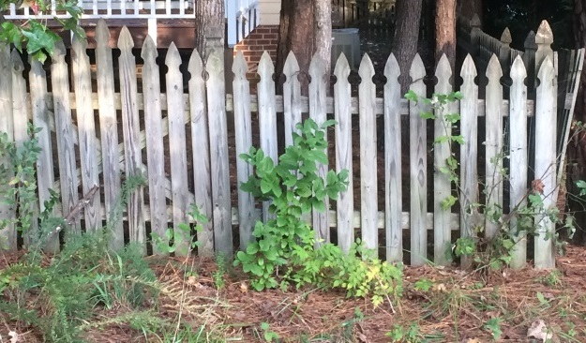 | 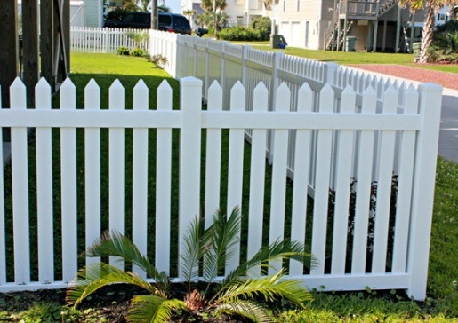

Picket-Dog-Eared | Picket–Flat Edge Scalloped
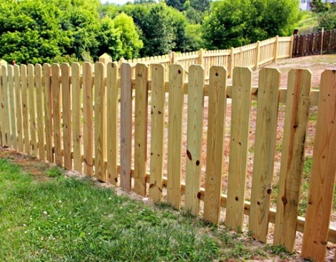 | 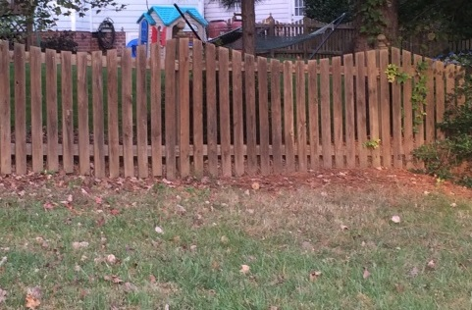

Aluminum Rail | Aluminum Rail
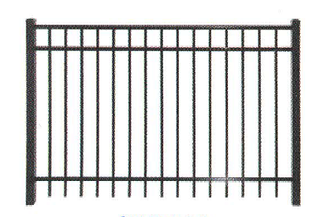 | 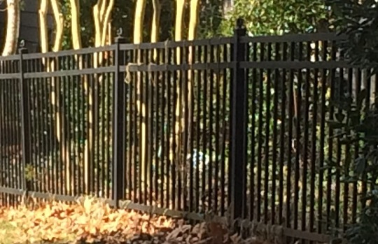

- Wooden picket style fences
The following guidelines are recommended for any wooden picket style fences.
- Acceptable picket styles include pointed, gothic, dog-eared or flat edge.
- Fences or gates can be scalloped.
- All fence lumber must be rot-resistant#2 or better pressure-treated wood.
- Posts: 4x4 inches set in cement;
- Runners: 4x2 inches;
- Pickets: minimum of ¾ inch thick and 2”–4½” inches in width; (used to be 6”)
- Spacing minimum of 1-½ inches of open space between pickets.
- Spacing must conform to local building code requirements.
Low maintenance vinyl picket fences should use similar picket sizes and spacing as noted for wooden fences.

Any wooden style fences that are adjacent to or visible along Downing Creek Parkway must be painted white. Natural weathering wood fences are acceptable in other locations.
All fences should be property maintained, repainted and repaired as needed by Property Owners, so that they do not become eyesores.

No approval is required for sealing re-staining or re-painting fences as long as the color is not changed.
- Illustrative Site Plan
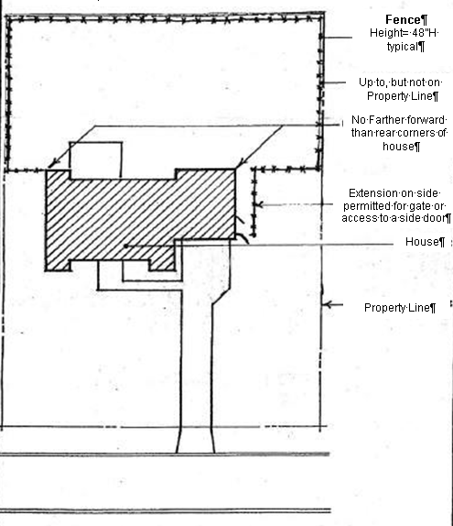

FLAGS, US (*AMA not required)
The Freedom to Display the American Flag Act of 2005 states: “ A condominium association, cooperative association or real estate management association may not adopt or enforce any policy, or enter into any agreement, that would restrict or prevent a member of the association from displaying the flag of the United States on residential property within the association with respect to which the member has separate ownership interest or a right to exclusive possession or use.

Any flag must be maintained and in good repair. Flags that are torn, substantially faded or frayed shall not be displayed.

GENERAL COMMUNITY CONSIDERATIONS
- Pets
Dog owners should be considerate of neighbors and their children by letting your dog relieve itself in the wooded areas and not on the jogging path or other common areas by the pool, playground or tennis courts. Dog owners are expected to clean up after their dog droppings in the common areas. Dog waste stations are provided along Downing Creek Parkway and around pond. As a reminder dog waste cannot be dropped in the pool or playground trash cans.

DCCA cannot help you resolve issues with excessive barking dogs. Please try to work these issues out with your neighbors. If you have a complaint about excessive dog barking is a violation of Durham City Ordinances, Section 11-1(b) (3). Please call Durham Animal Control at 919-560-0630 during normal business hours to file a complaint.

DCCA cannot help you resolve issues with loose dogs. If you see a dog running loose that you do not recognize, do not approach it. Call Animal Control at 560-0630. If you know the dog, please call the dog’s owner first.
- Parking
All homes in DCCA were built with a driveway sized to accommodate two parked cars off of the public streets. Durham ordinances allow for parking on public streets. Please be considerate of your neighbors and avoid street parking as much as possible. There is a concern that when cars are parked along our narrow streets, an emergency vehicle would not be able to get through. Please work out any parking issues with your neighbors.

Please be careful not to park on any the common area grass or landscaping anywhere in the neighborhood.

The Durham ordinances specifically prohibit
- Parking in front of a public or private driveway and blocking it from use.
- Parking within 25 feet from the intersection of curb lines
- When parking you cannot leave less than ten feet width of roadway free for the movement of vehicular traffic, except for temporary loading or unloading.
- Allowing any tree limbs, shrubbery, or other growth or obstruction to project into or overhang the public way closer than seven feet above the sidewalk or road an interfere with the free and safe passage of pedestrians or vehicular traffic.

Abandoned or junked vehicles are addressed in the provisions of G.S. 160A-303 .This ordinance prohibits keeping on private property motor vehicle that does not display a current license plate, is partially dismantled or wrecked, cannot be self-propelled, is more than 5 years old and appears to be worth less than $100. The city council and may enforce any such ordinance by removing the vehicle.

GENERAL PROPERTY APPEARANCE
The General Property Covenants, Part II, Land Management Controls and Part III Additional Restrictions Affecting Open Space Areas state the following:
In order to implement effective insect, reptile, rodent and woods fire control, Property Owners must maintain their property by mowing, removing, clearing, cutting or pruning underbrush, weeds and other unsightly growth.
Trash, garbage, sewage, sawdust or any unsightly or offensive material may not be dumped on open space areas or private open space areas. Nothing should be dumped on common property.
Each Property Owner shall provide a screening area to conceal unsightly objects or place them out of view. One or more method including landscaping, fences or walls may accomplish screening. These methods must conform to any minimum requirements outlined in these Architectural Guidelines
No mobile home, trailer, tent, boat, barn or other similar out building or structure shall be placed on any Residential Property at any time.

Please note if the DCCA BOD is put into position to take action to maintain or clean up a property due to dumping, neglect or other circumstances, these costs will billed back to the Homeowner and the property could be liened.

Part 1, Item 5 of the General Property Covenants states “It shall be the responsibility of each Property Owner, tenant, contractor or subcontractor to prevent the development of any unclean, unsightly, unkempt, unhealthy or unsafe conditions of buildings or grounds on any Property which shall ten to substantially decrease the beauty or safety of Downing Creek, the neighborhood as a whole or specific area. DCCA and its agents shall have the right to enter upon any Property for the purpose of correcting such conditions, including, but not limited to, the removal of trash which has collected on the Property, and the cost of such corrective action shall be paid by the Property Owner.”

GUTTERS
Properly installed, white prefinished (or color consistent with house trim), aluminum gutters do not require approval. Other colors or materials require approval. Approval is required if the gutters will cause a change in normal runoff patterns and quantities sufficient to impact drainage on adjacent properties.

LAMPPOSTS (*AMA not required)
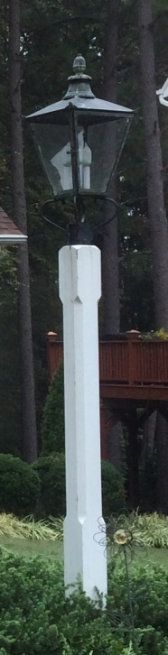
Original Lamp and Post

To maintain the aesthetic continuity of the streetscape, the height and lantern style for all lampposts are uniform throughout Downing Creek.

The typical installed height of the lamppost measured from the ground to the bottom of the lantern should be between 60 and 72 inches. Shorter heights are not acceptable. Lampposts are located in the front of the property, adjacent to driveway. Although there is not an exact distance placement from the street, they should be installed to maintain visual alignment with other lampposts on the street. Lampposts must be painted exterior white.

All homes within Downing Creek neighborhood with the exception of Downing Woods section are required to maintain or replace these lamps and lampposts.

The former Downing Woods section is the only grandfathered exception to lampposts and lanterns in the neighborhood. The Downing Woods section consists of 20 lots located beyond brick markers at end of Carriage Way and includes Blakely Drive. Downing Woods was annexed into Downing Creek Community Association in 1992

Lampposts and lanterns were not installed as part of the original streetscape of Downing Woods and these Property Owners will not be required retrofit their property.

New lamp posts may be obtained from The Woodwright Company, toll free 1-877-887-9663 or ordered at this website: http://www.thewoodwrightco.com/

The approved post is the 5"x5"x8' Square Chamfered Post Model WC-105 SC-8. As of February 2015, the current price for WC-105SC is $205.00 plus $35 shipping. The vendor is located in NC.
This solution is a very close style match to what exists today in the neighborhood. The posts from this company are made unfinished and designed to be installed over an in ground PVC pipe to prevent rotting at the base.
- Model WC105-SC-8
- 8' Tall
- Made of Western Red Cedar
- 24" PVC at bottom to avoid wood rot.
- Not pre-painted but can be primed and painted for an additional $40.00
- Shipping $35.00
- Installation instructions included.
Post Installation and Assembly Diagrams http://www.thewoodwrightco.com/postdiagrams.php
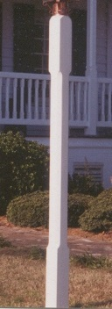  Square Chamfered Post  WC-105SC | 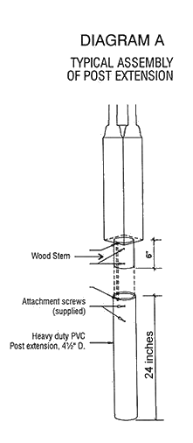 | 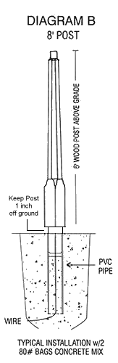

LANTERNS (*AMA not required)
The current approved replacement lantern is from Feiss Galena Collection-OL14407SB.
This lantern has a similar distinctive curved hook detail as found with the original lanterns.

http://www.feiss.com/55910/4---Light-Post/Pier-Lantern-OL14407SBL.html

 | STYLE NO.: OL14407SBL  4 - LIGHT POST/PIER LANTERN  Finish: Sable  Dimensions: L: 13 1/4'' W: 13 1/4'' H: 29''  Glass Plate: Glass in Clear Seeded finish  Lamping: (4) Candelabra Torpedo 60w Max  Bulbs not included.  Supplied with 12'' of wire | - Instructions (Trilingual (English, Spanish, and French))  - Parts Diagram (English)  - Specification Sheet  - PDF Specification Sheet

If your original lamp only needs minor repairs, you may be better off sending it back to the manufacturer.

You are also welcome to replace a broken lantern with a new handmade copper one like the original, but these are considerably more expensive. Last known cost was $1440. Please contact Garden Magic in Raleigh at (919) 821-1997 for details.

Provided for reference only- are the discontinued and original lantern specifications:
Discontinued OL1008ORB lantern specifications  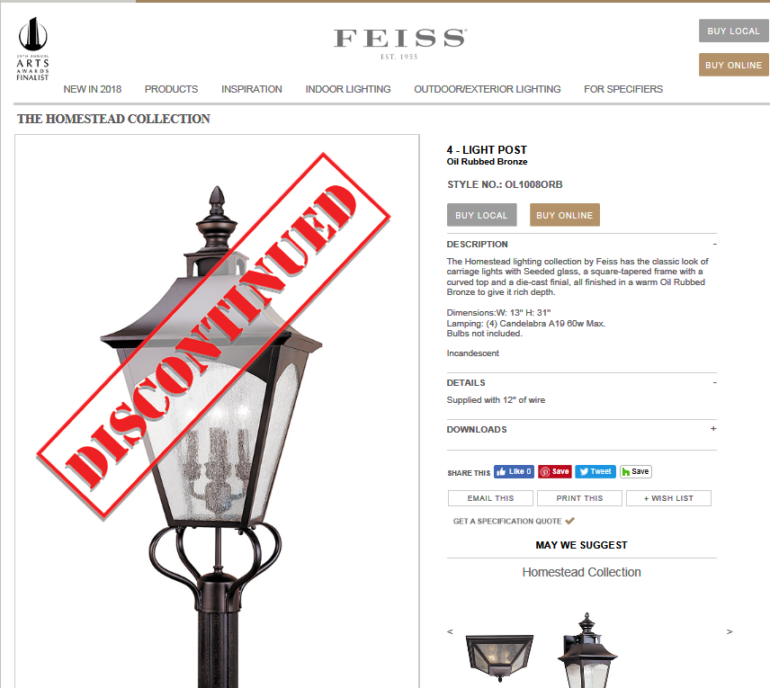 | Original lamp specifications:  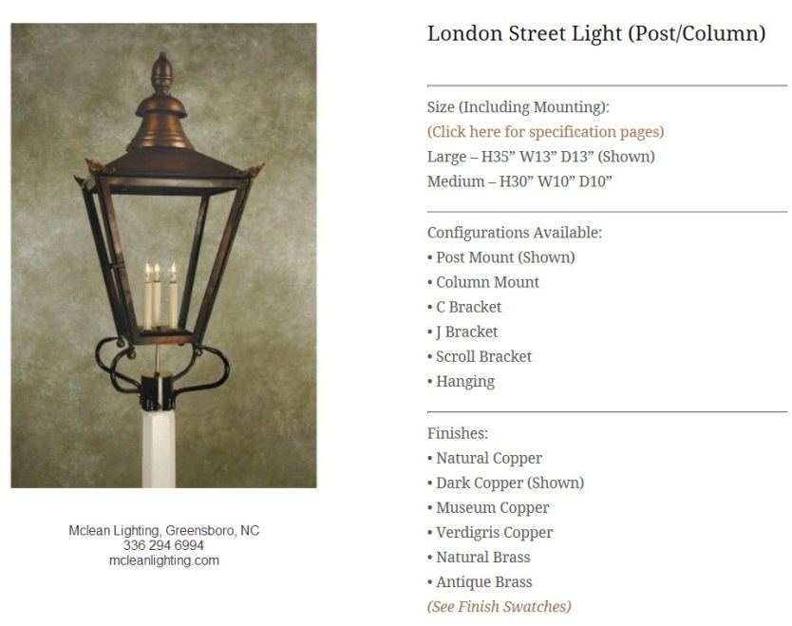
http:// www.feiss.com/product.search?SS=OL1008ORB | http://www.mcleanlighting.com/lighting-products/london-street-light-post-column/

LANDSCAPING
Landscaping is intended to consist of natural components. DCCA encourages the planning of shrubbery, plans and trees.

Landscape plans must be submitted for approval under the following conditions:
- A structural or alteration to the existing unit is made,
- A permanent, structural or decorative element is included such as an arbor, barbecue, gazebo in ground patio, retaining walls, play structure, sculpture or walkways or others.
- There is a change grading or drainage that could affect the neighboring properties including common areas.

All Landscaping projects should adhere to the tree removal, retaining walls, garden and deck
Homeowners are encouraged to seek professional landscaping architectural assistance when planning extensive landscape planting.

Vegetable gardens may be on the side or rear of the property ONLY if they are unobtrusive from the street and to adjacent property owners.

While lawn ornaments are acceptable accents, they should be positioned to blend into the natural features and not draw excessive attention to themselves. Lawn ornaments and sculptures that are taller than 3 feet require approval.

Natural areas and landscape beds may be placed in the front, rear and side yard and should be sized in proportion to the home and property. New landscape areas or beds greater than 200 square feet will require review and approval.

Trees, hedges, and shrubs that obstruct road signs or restrict the sight lines for vehicular traffic are not acceptable. In the event the existing vegetation is not properly maintained to prevent obstructions; then it may require cutting or removal of vegetation by Homeowner or by DCCA at the Homeowner’s expense.

MAILBOXES AND POSTS (*AMA not required)
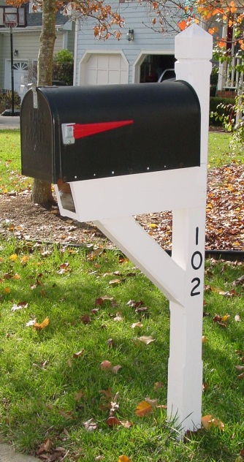
To maintain the aesthetic continuity of the streetscape, all mailboxes and posts are uniform throughout Downing Creek. Mailboxes and posts are visible part of the streetscape and need to be maintained. Mailboxes that are rusted dilapidated or in various states of disrepair are unacceptable and must be replaced.

Existing copper mailboxes with black doors and flags can be used as long as they are well maintained.

Replacement mailboxes should be metal in either black or copper finish and measure approximately 21 inches long, 8 inches wide, and 10.5 inches deep. This used to be known as “T2” size or large size.

Postal regulations require contrast between the flag and mailbox color. Black mailboxes in Downing Creek should have a red flag. The triangular shaped flag is preferred, but not required.

Replacement mailboxes can be purchased at local retailers such as Home Depot, Lowes or from internet retailers like Amazon.

Downing Creek has a custom mailbox post with built in newspaper/newsletter slot. The post must be painted exterior white with routed or applied black numbers for the house address.

Decorative adhesive or plastic mailbox covers should not be used on mailboxes. However, decorative mini flags can be mounted to posts. Temporary holiday decorations are permissible.

“According to USPS mailboxes are generally installed at a height of 41-45 inches from the road surface to inside floor of the mailbox or point of mail entry and are set back 6-8 inches from front face of curb or road edge to mail box door.”

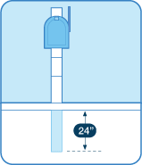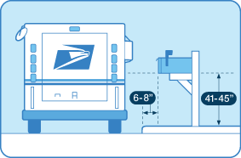
Be sure there is there is clear access to your mailbox. Your carrier may not deliver your mail if there’s a car, shrub, snowdrift, or unfriendly dog or any other obstructions in front of it

PAINTING/ EXTERIOR COLOR CHANGES
- General Painting Guidelines
Painting the exterior structure of a dwelling includes the colors for the siding, trim, shutters, windows, and doors, etc.

Wood surfaces must be painted. Stained or natural wood finishes are not allowed for siding or trim. Exceptions are decks and related railing and fences. No approval is required for re-staining previously approved stain and fences as long as color has not changed.

No masonry or brick surfaces may be painted.

Selected colors must be harmonious with other colors used on the structure such as roofing and brick, and must be harmonious with the colors used in the neighborhood. More than 260 colors are available on the approved DCCA color palette which is based on Sherwin Williams paint color selections.(See Exhibit B) From time to time the color palette will be reviewed and updated.

A copy of the approved DCCA color palette book is available for short term loan from the DCCA CAM. The paint manufacturer, colors name(s) and number(s) all should be listed on the DCCA AMA request
- If you select a paint color from another manufacturer, please provide 3 paint chip samples. If possible, it will be matched an existing approved color palette selection.
- If there is no clear match, allow extra time to process applications requesting new colors.
- New colors must be found to be aesthetically compatible with the existing colors on the palette. The colors most likely to be accepted are those, which are shades from existing colors, and colors in muted earth tones.
- Color Selection Tips
- Lighting can make a big difference. Look at the paint chip in exterior light, preferably on both a sunny and a cloudy day. Paint chips cannot be evaluated in the evening under incandescent light.
- Blues and yellows in particular seem to look a lot brighter on the house.
When in doubt, it’s a good idea to purchase a quart of the color and paint a small sample on the house to evaluate in several lighting situations, and at several distances.
- The DCCA BOD may require seeing a sample painted on the house when we are in doubt.
- In general, neighboring houses should be painted in different colors for visual interest.
- A paint color should complement the colors of adjacent homes.
- Contrasting trim is found on most homes in Downing Creek and is highly encouraged. Contrasting color may be lighter or darker, and contrast may be strong or subtle.
- Repainting- ANY Color Modifications
If a Homeowner plans to repaint and change any of the colors (base, trim, shutters and doors) on the house, the DCCA AMA request form must be submitted and be reviewed by AAC and selections approved by the DCCA BOD.

The paint manufacturer, colors name(s) and number(s) all should be listed on the DCCA AMA request clearly noting which colors will be used on the main siding, trim, shutters, windows, and doors, etc.

- Repainting – SAME Colors
If the Homeowner plans to repaint a house with the SAME colors (base, trim, shutters, and doors), as existing; you must first verify if the existing paint colors are still included on approved DCCA color palette.

If the colors ARE NOT on the approved palette, then the request will be treated in accordance with item C: Repainting-ANY Color Modification

If the existing colors ARE on the approved DCCA palette, the Homeowner must still submit a signed DCCA AMA request form including: the paint manufacturer, colors name(s) and number(s) all should be listed on the DCCA AMA request clearly noting which colors will be used on the main siding, trim, shutters, windows, and doors, etc.

However, the Homeowner may commence with repainting work once the AMA is acknowledged by the DCCA CAM, only if colors are on approved DCCA palette.

Be advised, if your scope of work deviates from the submitted application, you could be required to make changes at your expense

- Sherwin Williams Downing Creek Discount
In 2003, Sherwin Williams has established a preferred customer discount program for Downing Creek HOA the account number 9183-7826-6

The pricing established under this card is better than sales pricing and consistent with “contractor” discounts. It is generally 205 off regular price or 10% off sales items.

The Chapel Hill store is located at 1507 East Franklin Street, Chapel Hill, NC 27517

You can view colors on Sherwin Williams’s website: Find & Explore Color

PATIOS
Patios should be located at the rear of the house and be consistent with the size of the house and yard. Consideration should be given to visual impact. Patios should be constructed with natural colored concrete, slate, flagstone, brick, or wood left to weather naturally. If constructed of stone, brick, etc., they must be set in sand.

Note these patios may count as impervious surface.

PLAY and RECREATIONAL EQUIPMENT (*AMA not required)
Play equipment, includes but is not limited to swing sets, slides, sandboxes, jungle gyms, climbing structures, and play houses. Moveable, temporary items such as bikes, wagons, and similar items are not considered play equipment.

Recreational equipment includes but is not limited to basketball goals, trampolines, horseshoe pits and permanent volleyball courts.

Play equipment should be placed in the rear yard and may not be placed on Common Property. The Homeowner should take into account the size of the lot, the size of the equipment, material, design, and the amount of visual screening, which may be needed in relation to adjacent properties.

If the play equipment, or structure is anchored in the ground and cannot be easily moved, it will be treated as a Freestanding Structure.

Fixed basketball backboards location must be approved. Freestanding or mobile basketball backboard must be on driveway and not placed on any part of the public road.

All playground and recreational equipment must be maintained in a safe condition and kept visually pleasing to the community a surrounding environment. Playground equipment which has fallen in disrepair should be removed from the property.

RAIN BARRELS (*AMA not required)
Rain Barrels are valuable in conserving water and their use is encouraged. Installations of rain barrels do not need approval, provided they are:
- No larger than 80 gallons
- Earth-toned or dark colors such as black, dark green, dark brown, etc.
- Screened from visibility from with shrubs or trees if possible to minimize the visual impact from a public way or adjoining property

REPAIRS(*AMA not required)
Homeowners may make any general repairs to exterior of house as needed without submitting an AA. The repair or patch must match original style, materials, and colors. Repairs when completed should not be visibly different from original appearance.

Homeowners making any changes to exterior appearance are required to submit an AMA and wait for approval by the DCCA BOD.

RETAINING WALLS
Retaining walls should be unobtrusive and compatible with the aesthetics of Downing Creek. Natural building materials may be brick, natural stone, square corner pressure treated timbers or concrete.

Retaining walls often provide a border for a flowerbed or landscape bed. There is no explicit height limit, but compatibility with surrounding area will be considered. Retaining wall should be built to a minimum height needed to serve their function. Be aware that when a wall holds back 4 feet or more of fill, NC Building Code requires the wall to be designed by an engineer and have a building permit.

All retaining wall must be properly secured to prevent collapse. Any request for a wall over three feet in height shall include detailed specifications for anchoring the wall. The Homeowner is responsible for ensuring that all retaining walls meet Durham City-County zoning requirements, NC Building codes and requesting all required permits.

ROOF REPLACEMENTS
DCCA BOD favors replacement asphalt roof shingle in charcoal grey, medium gray or black. The original developer of Downing Creek encouraged the use of heavy asphalt shingles such as GAF Timberline #340, Owens Corning-Charcoal or Genstar-Charcoal.

Examples of three tab strip shingles and laminated shingles also known as three dimensional or architectural shingles are found within the neighborhood.
If the roof will be replaced with charcoal grey, medium gray or black asphalt shingles, then the Homeowner must still submit a signed DCCA AMA request form. The scope of work including shingle manufacturer and grade and color of shingle should all be listed on the DCCA AMA request

However, the Homeowner may commence with reroofing work once the AMA is acknowledged by the DCCA CAM.

Be advised, if your scope of work deviates from the submitted application, you could be required to make changes at your expense

The DCCA BOD recognizes that lighter roofs may be more energy efficient and will consider alternatives roof colors, styles and/or materials on a case by cases basis. Please provide the product name and specification detail sufficient enough to completely identify the product you wish to use along with photos or samples showing the style and colors proposed.
Standing seam metal copper roofs are only acceptable as small decorative element over windows and not as a material on the main dwelling roof.
Additional general information on roofing materials and systems can be found on the internet. These two sites provide links to various manufacturers and several provide tools that will help you visualize roofing and to find energy efficient options.
Asphalt Roofing Manufacturers Association,
http://www.asphaltroofing.org/resources_steep_man.html

National Roofing Contractors Association
http://www.everybodyneedsaroof.com/

SIDING
Most of the homes in Downing Creek were originally sided with hardboard (e.g. Masonite) clapboard or lap siding smooth or beaded.
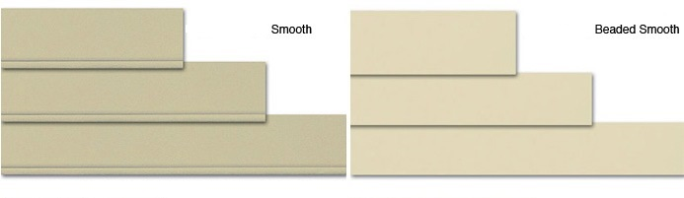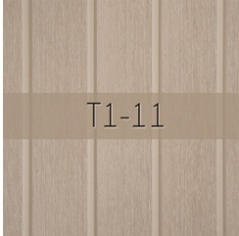
The original Building Guidelines of Downing Creek prohibited the use of Aluminum siding or T1-11 siding at all. .

The DCCA BOD favors siding replacements of good quality fiber cement (e.g. Hardie Plank), but understands this is a premium price alternative. Other siding alternatives such as vinyl siding will be considered on a case by case basis.

- Fiber Cement Siding
If the siding is replaced with either identical or alternative materials such as fiber cement (e.g. Hardie Plank clap board siding smooth or beaded) that closely mimics the original horizontal siding in size, texture, appearance and is painted the same color, this is considered maintenance.

Homeowner must still submit a signed DCCA AMA request form. DCCA AMA request should document the scope of work stating the siding type, style and paint color name and number. However, the Homeowner may commence with residing once the AMA is acknowledged by the DCCA CAM.

Be advised, if your scope of work deviates from the submitted application, you could be required to make changes at your expense

Tips: Fiber cement materials are heavy. Installation requires use specialty tool and techniques to cut and nail it. Improperly treated cement based products can be mildew magnets. Always follow manufacturer’s specific installation instructions. .

Fiber cement products contain respirable crystalline silica. Please follow recommended cutting practices to help reduce the exposure risks associated with silica dust.
- Vinyl siding
All Vinyl siding products applications will be reviewed and considered on a case by case basis. The siding style, texture, color, the overall appearance of the product and its impact and suitability with other homes in the community will be factors in the decision. Any replacement of the existing vinyl siding with a similar style vinyl does not constitute pre-approval by DCCA BOD. Because of the considerable expense involved with home siding, residents are urged to carefully review the guidelines for vinyl siding.
Higher quality premium vinyl siding are typically more expensive, but will be required to meet these guidelines. The following site may help http://www.vinylsiding.org/
- The minimum thickness of vinyl siding permitted is .044” This is a premium grade vinyl.
- Please provide the manufacturer, product name and specification detail sufficient enough to completely identify the product you wish to use.
- Documentation must be provided listing
  - the product thickness,
  - ASTM E119 - Standard Test Methods for Fire Tests of Building Construction and Materials, which indicates that the material is not a fire accelerant,
  - ASTM D3679 - Standard Specification for Rigid Poly (Vinyl Chloride) (PVC) Siding. which indicates the siding has met the requirements for the testing methods,
  - and the wind rating of the vinyl siding submitted
- The style of vinyl should be a traditional, clapboard or beaded style, which is similar in size, texture, and appearance to other siding styles found in neighborhood.
- Color selection should be matched to a paint color found on the approved DCCA paint palette.
- A sample piece of the vinyl siding in the style and color being considered must be submitted for review.
- The use of vinyl siding on sheds; playhouses, etc. must also follow these guidelines.
- Installation of vinyl siding must meet or exceed the standards in the Vinyl Siding Installation handbook of the Vinyl Siding Institute.
- It is recommended, but not required that a type of rigid board insulation be used in conjunction with siding.
- In any clear run of siding measuring 12’ or less, no joints are permitted. In clear runs of 12’ or more, joints should be in a random pattern in the wall. Do not “stair step” joint patterns. Panels of lengths less than 12’ shall be used at the ends of clear runs only.
- Stagger the siding ends laps so that no two courses (rows of panels) are aligned vertically, unless separated by at least three courses.
- Overlap joints away from entrances and greatest point of traffic. This will improve overall appearance of installation

SIGNS (*AMA not required)
All signs in and around DCCA shall be in compliance with Article 11: Sign Standards of the
Durham Unified Development Ordinance (UDO) amended 9/1/2014. Any signs not in accordance with the ordinance or the following rules will be removed.
Directional and open house signs may only be placed at the entrances to the neighborhood or on any Downing Creek common property between Friday evening and Monday morning the weekend of the event. These signs must be removed by noon Monday following the advertised event or they will be removed by DCCA.
Signs must be mounted on a wooden or metal standard placed in the ground, not nailed to a tree. No signs may be attached to traffic signage or other permanent signs at any time.

SOLAR POWER (Passive and Active)
All requests for solar collectors that gather solar radiation as a substitute for traditional energy for water heating, active space heating and cooling, passive heating, or generating electricity for a residential property will require review and approval.

The North Carolina legislature enacted N.C.G.S. §22B-20, effective October 1, 2007, which has a limited effect on a Homeowners association’s authority to regulate placement of solar panels on single family dwellings. The intent of the statute, generally, is to encourage the use of solar resources and to discourage Homeowners associations from making the installation of solar technologies so cost prohibitive as to effectively discourage Homeowners from using this alternate form of energy.

Generally speaking, a Homeowners association may prohibit solar panels completely if they are visible on the house’s facade or slope of roof that is facing any area open to common or public access.

The new law also provides that if not visible from the street of common areas, the Homeowners association may still regulate the location and screening of the solar panels, as long as reasonable use of the solar panels can be made.

STORM DOORS
White (or color matching the door or its trim) storm doors with full height glass without cross members need no approval. Other styles and colors of storm doors do required approval.

SPAS/HOT TUBS/SWIMMING POOLS
Spas, Hot tubs and Swimming Pools will be reviewed on a case by case basis. Above ground swimming pools will not be approved. Small temporary portable play pools are allowed during summer months.

An emphasis will be placed on:
- Screening systems to minimize the visual impact from a public way or adjoining property
- Safety and security to prevent access when not in use.

- Location
Spas, Hot tubs must be located in the rear yard and be an integral part of a deck, patio or landscaping. Swimming pools must be located in the rear yard and away from adjacent properties.

Spas, hot tubs or swimming pool may not encroach on utility easements or infringe upon DCCA Common Property.

When selecting the size and location for a spa, hot tub or swimming pool, views from adjacent properties must be considered so that the noise of the mechanical equipment does not adversely affect adjacent properties. Visual screening may be required. As a courtesy, please discuss your plans with your neighbors

Durham City-County zoning laws (Section 7.41 under “Supplemental Requirements”) specifically state “Private swimming pools as well as the decking and equipment associated with the pool on single family, duplex, and triplex lots shall not be located in the front or side yards and not be closer than 5 feet to the rear property line. The pool shall be completely enclosed by an opaque fence at least 6 feet in height if any portion of the pool or pool decking is within 20 feet of a property line. Pools not within 20 feet of the property line shall be enclosed with an opaque fence that is at least 4 feet in height. The exterior walls of the residence or buildings may be incorporated as a portion of the fence to create a fully enclosed area around the pool. All fence openings into the pool area shall be equipped with self-closing and self-latching gates. These regulations shall apply to in- ground and above ground swimming pools which have a water depth over 24 inches or have a surface area of at least 100 square feet. Security measures shall be installed to prevent access to the pool when it is not intended to be used.”

The depth definition (24”) in the next to last sentence above may classify many hot tubs as pools according to Durham City-County zoning laws, which means that those hot tubs will be subject to the more restrictive fence rules cited above even if they are covered hot tubs. Hot tubs with a water depth less than 24” must also be confined to the rear yard. Care should be taken to locate pools and hot tubs so as to avoid potential hazards (i.e., electrocution, drowning).

The understructure of the spa/hot tub set into above ground decks must be screened, so they will not be seen from adjacent properties.

Pumps, machinery, pipes and wiring related to pool or hot tub must be concealed in a manner to avoid offensive visual appearance and minimize noise production or transmission of such noise to adjacent and nearby properties.

Homeowners are responsible for ensuring that installation meets or exceeds all applicable codes, zoning requirements, regulations, ordinances, permit requirements and inspection requirements of Durham City-County

Swimming pools, including decks and associated security fencing must be in scale and designed to conform to the character of the property on which they are located. Refer to Deck and Fencing sections within this document for specific requirements.

TREES and TREE REMOVAL
Mature trees lend character and value to Downing Creek, and are a benefit to all who live near them. Because trees affect the value of all neighboring property and not just the lot on which they grow, special attention is given to them.
- Tree Removal
Written requests must be submitted to DCCA CAM for approval by the DCCA BOD to remove any healthy tree with a trunk diameter exceeding 6 inches within 2 feet from the ground, unless the tree can be shown to be diseased, dead or an immediate danger. Fines may be issued for trees which are removed without first obtaining approval.

Trees damaged by storms, other accidents, or that pose an immediate threat to life or property on the Homeowner’s property, may be removed by Homeowner without prior approval.

A tree located within ten feet of the house (meaning the primary dwelling and not a deck or shed) that is dead or significantly damaged from natural causes may be removed by home owner without prior approval. However, before such a tree is removed, the Homeowner should document the condition of the tree with a photo and/or statement from a certified arborist in the event of a dispute about removal of the tree.

The following website may be helpful.
http://www.isa-arbor.com/findanarborist/findanarborist.aspx

Please report any dead trees or other issues on common property near your home to DCCA CAM. The DCCA regularly removes dead trees of which it is aware.

Trees, hedges, and shrubs that obstruct road signs or restrict the sight lines for vehicular traffic are not acceptable. In the event that existing vegetation is not maintained to prevent safety obstructions; the vegetation will be cut or removed by DCCA at the Homeowner’s expense.
- Street Trees
Trees that were planted along the streets when Downing Creek was developed were standardized to enhance the streetscape design with a traditional landscape feature. These trees contribute to the personality and character and uniqueness of our neighborhood and are enhanced each year as the trees mature.

Because these street trees are part of a unified planting, there are rules that apply to them which do not apply to the rest of the landscaping on our Property Owner's property. Property Owners are expected to care for these street trees and may not remove them. If a problem develops with one of these street trees, the DCCA CAM must be notified.
The Property Owners must replace these trees with the approved species and cultivar for their street.

If the replacement is not the same as the tree that was lost, then the DCCA CAM must be contacted to approve the location and spacing of the new tree. Otherwise, the tree must be replaced with the same like and kind in the same location or, with the Board's approval, as close to it as reasonably possible. The currently approved street trees for Downing Creek are listed below; however please check the http://www.downingcreek.org/ website for any updates or changes.

- Approved Street Trees
Street | Original Tree | Approved Tree
Cranebridge Place |  | Contact Cranebridge Association
Jamestown Place |  | White Crepe Myrtle (probably ‘Natchez’) | 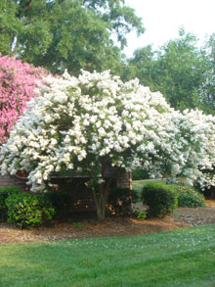
Dunmore Pl  Belfair Place  Killington Court | Bradford Pear | Zelkova 'Green Vase' | 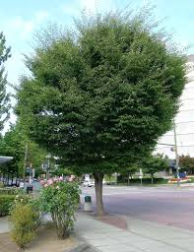
Chedworth Court | purple leaved plum | Lace Bark Elm | 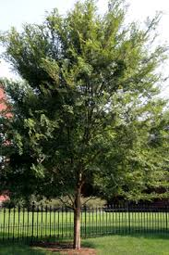
Bearkling Place  Benwick Court  Falmouth Court |  | Red Maple | 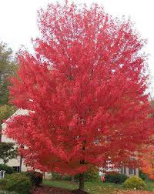
Street | Original Tree | Approved Tree
Carriage Way  Daventry Court  Blakely Drive |  | Northern Pin Oak | 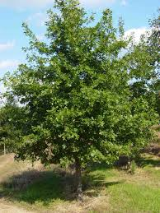
Beecham Way  Tanyard Court |  | Willow Oak | 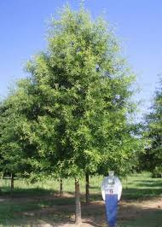
Winslow Place  Fenton Place | Bradford Pear | Lace Bark Elm
Copeland Way  Balthrope Place |  | Red Maple

EXHIBIT A - DOWNING CREEK IMPERVIOUS SURFACE
This email from Durham City- County Planning department has been provided for your general information. Any questions on impervious requirements should be directed to them.
From: Doty, Dennis <Dennis.Doty@durhamnc.gov>
To: Rebecca Board <beccacyberlily@gmail.com>
Cc: DCCA Board <board@downingcreek.org>
Sent: Tue, Jun 5, 2012 11:38 am
Subject: Downing Creek Impervious Surface
Rebecca thanks for your patience while we researched your questions. We have gone through our own records and the available plats online and can offer you the following information regarding impervious surface limits in Downing Creek (Downing Place is included in this as well).
- This area was under the watershed overlay when the overlay was first adopted in 1985. This means that when Downing Creek was platted and constructed in the early 1990’s, it was under a maximum impervious surface of 30%. (My earlier email to one of the residents stating that they were exempt was incorrect since I was looking at the City map for this area and not the County map since this area was in the County’s jurisdiction until it was annexed in 1993. My apologies for that error as I was not aware Downing Creek started in the County. A detail from the County map showing the areas under watershed is shown below. The areas in blue are inside the watershed overlay).
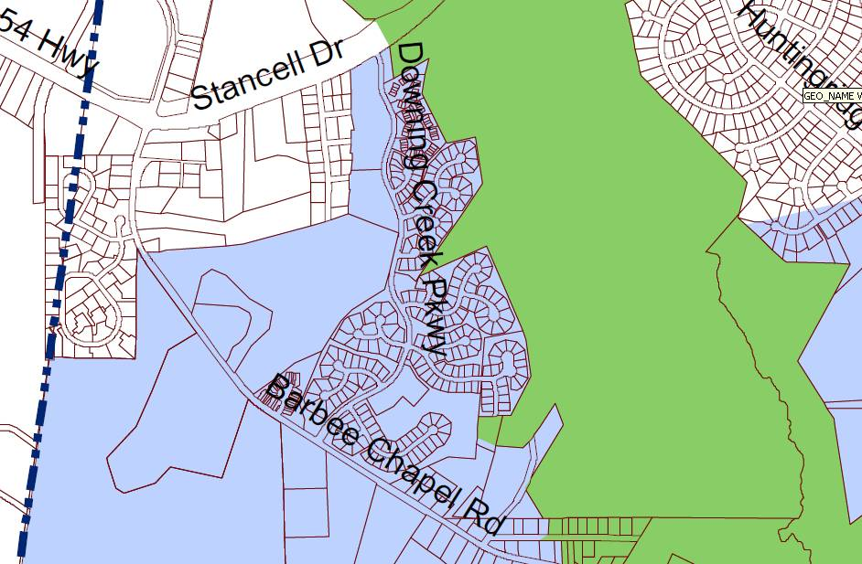

- Under the current watershed regulations, a new subdivision in this area would be limited to 24% impervious surface but our current ordinance allows existing single family lots to be reviewed under the watershed regulations in existence at the time the lots were created (see attached copy of Sec. 8.7.3B - there is no exemption for impervious surface which was existing prior to 1994 for single family lots. This was clarified recently and only Sec. 8.7.3B applies). That means 30% impervious surface for Downing Creek. Please note, however, that if a lot is changed, such as moving a lot line, then the original 30% no longer applies and the current 24% applies since we would view this altered lot as a new lot.
- The only exception we have found for this is all 14 lots on Jamestown Place. This was originally set up at 32.66% per lot as shown on the attached tabulation sheet. As you can see, for that particular phase the developer was keeping tabs on each lot so that the overall impervious for the entire phase did not exceed 32.66%. It does not appear any new information was given past 1997.
As mentioned, this area was in the County when it was originally constructed. Unfortunately, little if any of the original County records made it when the City and County Planning Departments were combined (and when the City and County Inspections were merged later). Everything we can find, though, indicates 30% impervious with the exception of Jamestown Place as mentioned above. This includes a plat from 1994 which covers Balthrope Place and part of Copeland Drive (Plat Book 130, Page 178) which specifically states “All lots are limited to 30% impervious surface coverage.”
My apologies for any confusion created by previous queries. If any of this information generates new questions, please let us know.
Dennis Doty
Customer Service Center
Durham City-County Planning Department
101 City Hall Plaza
Durham, NC 27701
(919)560-4137 ext. 28252
Dennis.Doty@durhamnc.gov

EXHIBIT B – DCCA APPROVED PAINT COLORS
 | Sherwin Williams FANDECK | SW COLOR NO. | COLOR NAME | RED | GREEN | BLUE | Mapping to Original Martin Senour  Colors Palette
 | approved accent | 2809 | Rookwood Shutter Green | 48 | 59 | 57 | Market Square Tavern Green ,W85-0620
 | approved palette | 2813 | Downing Straw | 198 | 173 | 121
 | approved accent | 2816 | Rookwood Dark Green | 84 | 94 | 75 | Benjamin Powell House Green,W85-1089
 | approved palette | 2819 | Downing Slate | 116 | 123 | 130
 | approved palette | 2820 | Downing Earth | 137 | 125 | 104
 | approved palette | 2821 | Downing Stone | 163 | 161 | 148
 | approved palette | 2822 | Downing Sand | 203 | 191 | 166
 | approved accent | 2847 | Roycroft Bottle Green | 49 | 64 | 56 | Benjamin Powell House Green,W85-1089
 | approved palette | 2857 | Peace Yellow | 232 | 210 | 154
 | approved palette | 2865 | Classic Yellow | 245 | 218 | 145
 | approved accent | 2901 | Wine Country | 96 | 34 | 52
 | approved accent | 2906 | Crimson Red | 113 | 25 | 34
 | approved accent - DOOR only | 2912 | Chanticleer | 135 | 0 | 0
 | approved accent | 2923 | Bramble Bush | 80 | 54 | 41 | William Finnie House Brown,W85-0225
 | approved accent | 2924 | Woodsy Brown | 61 | 39 | 29
 | approved accent | 2926 | Iron Gate | 63 | 53 | 43 | Bryan House Chocolate,W85-1068
 | approved accent | 2927 | Weathervane | 44 | 32 | 26 | Chowning’s Tavern Brown,W85-1070
 | approved accent | 2929 | Garden Path | 66 | 67 | 48
 | approved accent | 2930 | Marsh Fern | 76 | 69 | 39 | George Davenport House Green,W85-1071
 | approved accent | 2932 | Perennial Green | 27` | 82 | 54 | Believe SW discontinued color verify?
 | approved accent | 2933 | Greenhouse | 33 | 75 | 45 | Believe SW discontinued color verify?
 | approved accent | 2934 | Clover | 5 | 66 | 36 | Believe SW discontinued color verify?
 | approved accent | 2935 | English Ivy | 0 | 47 | 36 | Believe SW discontinued color verify?
 | approved accent | 2936 | Black Emerald | 18 | 34 | 29 | Burdett’s Ordinary Black Green,W85-0625
 | approved accent | 2939 | Blue Hill | 30 | 69 | 77 | Believe SW discontinued color verify?
 | approved accent | 2942 | Liberty Blue | 14 | 21 | 49 | Believe SW discontinued color verify?
 | approved palette, (Strip 1) | 6000 | Snowfall | 225 | 223 | 219
 | approved palette, (Strip 1) | 6001 | Grayish | 208 | 203 | 200
 | approved palette, (Strip 1) | 6002 | Essential Gray | 188 | 184 | 181
 | approved palette, (Strip 1) | 6003 | Proper Gray | 174 | 169 | 166
 | approved palette, (Strip 1) | 6004 | Mink | 134 | 126 | 121
 | approved palette, (Strip 1) | 6005 | Folkstone | 111 | 104 | 100
 | approved palette, (Strip 1) | 6006 | Black Bean | 64 | 51 | 46
 | approved accent, (Strip 2) | 6013 | Bitter Chocolate | 79 | 61 | 61
 | approved accent, (Strip 3) | 6020 | Marooned | 80 | 52 | 51
 | approved accent, (Strip 4) | 6027 | Cordovan | 96 | 61 | 63
 | approved palette, (Strip 6) | 6035 | Gauzy White | 228 | 221 | 214
 | approved palette, (Strip 6) | 6036 | Angora | 210 | 199 | 191
 | approved palette, (Strip 6) | 6037 | Temperate Taupe | 192 | 179 | 171
 | approved palette, (Strip 6) | 6038 | Truly Taupe | 175 | 162 | 154
 | approved palette, (Strip 6) | 6039 | Poised Taupe | 143 | 131 | 124
 | Sherwin Williams FANDECK | SW COLOR NO. | COLOR NAME | RED | GREEN | BLUE | Mapping to Original Martin Senour  Colors Palette
 | approved palette, (Strip 6) | 6040 | Less Brown | 120 | 107 | 100
 | approved palette, (Strip 6) | 6040 | Less Brown | 120 | 107 | 100
 | approved palette, (Strip 6) | 6041 | Otter | 90 | 74 | 65
 | approved accent, (Strip 8) | 6055 | Fiery Brown | 94 | 57 | 47
 | old palette match, (Strip 10) Add | 6065 | Bona Fide Beige | 204 | 187 | 172 | Nicolson Store Red,W83-1087
 | old palette match, (Strip 10) Add | 6068 | Brevity Brown | 113 | 84 | 66 | Robert Carter Tobacco, W84-0230
 | approved palette, (Strip 11) | 6070 | Heron Plume | 230 | 226 | 217
 | approved palette, (Strip 11) | 6071 | Popular Gray | 213 | 206 | 196
 | approved palette, (Strip 11) | 6072 | Versatile Gray | 194 | 184 | 172
 | approved palette, (Strip 11) | 6073 | Perfect Greige | 181 | 171 | 158
 | approved palette, (Strip 11) | 6074 | Spalding Gray | 145 | 132 | 121 | Peyton Randolph Gray, W82-10860
 | approved palette, (Strip 11) | 6075 | Garret Gray | 119 | 107 | 98
 | approved palette, (Strip 11) | 6076 | Turkish Coffee | 79 | 60 | 50
 | approved palette, (Strip 12) | 6077 | Everyday White | 228 | 221 | 212
 | approved palette, (Strip 12) | 6078 | Realist Beige | 211 | 202 | 189
 | approved palette, (Strip 12) | 6079 | Diverse Beige | 196 | 183 | 168
 | approved palette, (Strip 12) | 6080 | Utterly Beige | 181 | 168 | 151 | James Moir Shop Fawn,W82-1080
 | approved palette, (Strip 12) | 6081 | Down Home | 144 | 123 | 102 | Nicolson Store Taupe,W83-1082
 | approved palette, (Strip 12) | 6082 | Cobble Brown | 124 | 105 | 87
 | approved palette, (Strip 12) | 6083 | Sable | 93 | 76 | 61 | Palmer House Kitchen Brown,W85-1085
 | approved palette, (Strip 13) | 6084 | Modest White | 231 | 222 | 212
 | approved palette, (Strip 13) | 6085 | Simplify Beige | 213 | 200 | 185
 | approved palette, (Strip 13) | 6086 | Sand Dune | 196 | 178 | 160
 | approved palette, (Strip 13) | 6087 | Trusty Tan | 181 | 162 | 143
 | approved palette, (Strip 13) | 6088 | Nuthatch | 144 | 120 | 98
 | approved palette, (Strip 13) | 6089 | Grounded | 121 | 94 | 72
 | approved palette, (Strip 13) | 6090 | Java | 103 | 76 | 58
 | old palette match, (Strip 105) Add | 6102 | Portabello | 148 | 126 | 99 | Raleigh Tavern Sorrell,W83-1091
 | approved palette, (Strip 16) | 6105 | Divine White | 231 | 222 | 206 | Porcelain 0053
 | approved palette, (Strip 16) | 6106 | Kilim Beige | 215 | 201 | 176
 | approved palette, (Strip 16) | 6107 | Nomadic Desert | 198 | 180 | 152
 | approved palette, (Strip 16) | 6108 | Latte | 186 | 165 | 135
 | approved palette, (Strip 16) | 6109 | Hopsack | 158 | 134 | 101
 | approved palette, (Strip 16) | 6110 | Steady Brown | 136 | 110 | 75
 | approved palette, (Strip 16) | 6111 | Coconut Husk | 111 | 89 | 60
 | approved palette, (Strip 17) | 6112 | Biscuit | 235 | 223 | 204
 | approved palette, (Strip 17) | 6113 | Interactive Cream | 227 | 206 | 173
 | approved palette, (Strip 17) | 6114 | Bagel | 214 | 185 | 147
 | approved palette, (Strip 17) | 6115 | Totally Tan | 203 | 171 | 130
 | approved palette, (Strip 17) | 6116 | Tatami Tan | 185 | 147 | 101 | Ludwell Tenement Gold,W83-1078
 | approved palette, (Strip 17) | 6117 | Smokey Topaz | 165 | 127 | 84
 | approved palette, (Strip 17) | 6118 | Leather Bound | 140 | 102 | 58
 | Sherwin Williams FANDECK | SW COLOR NO. | COLOR NAME | RED | GREEN | BLUE | Mapping to Original Martin Senour  Colors Palette
 | approved palette, (Strip 18, C) | 6119 | Antique White | 231 | 222 | 199
 | approved palette, (Strip 18) | 6120 | Believable Buff | 217 | 202 | 168 | Bracken Tenement Biscuit,W81-1064
 | approved palette, (Strip 18) | 6121 | Whole Wheat | 204 | 186 | 146
 | approved palette, (Strip 18) | 6122 | Camelback | 195 | 175 | 134
 | approved palette, (Strip 18) | 6123 | Baguette | 177 | 151 | 104 | Grissell Hay Lodging House Gold,W83-1060
 | approved palette, (Strip 18) | 6124 | Cardboard | 158 | 130 | 91
 | approved palette, (Strip 18) | 6125 | Craft Paper | 137 | 107 | 73 | George Pitt House Caramel,W84-1087
 | approved palette, (Strip 19) | 6126 | Navajo White | 234 | 223 | 201
 | approved palette, (Strip 19) | 6127 | Ivoire | 226 | 209 | 172
 | approved palette, (Strip 19) | 6128 | Blonde | 218 | 193 | 146 | William Bryd III House Ivory, W81-1073 Sandhill 30YY 55/238
 | approved palette, (Strip 19) | 6129 | Restrained Gold | 208 | 183 | 133
 | approved palette, (Strip 19) | 6130 | Mannered Gold | 191 | 159 | 100
 | approved palette, (Strip 19) | 6131 | Chamois | 173 | 141 | 84
 | approved palette, (Strip 19) | 6132 | Relic Bronze | 144 | 114 | 61
 | approved palette, (Strip 20) | 6133 | Muslin | 232 | 225 | 201
 | approved palette, (Strip 20) | 6134 | Netsuke | 222 | 210 | 176
 | approved palette, (Strip 20) | 6135 | Ecru | 207 | 193 | 151
 | approved palette, (Strip 20) | 6136 | Harmonic Tan | 195 | 180 | 137
 | approved palette, (Strip 20) | 6137 | Burlap | 171 | 155 | 115 | Brush-Everard Gold,W83-1060
 | approved palette, (Strip 20) | 6138 | Artifact | 153 | 136 | 97
 | approved palette, (Strip 20) | 6139 | Mossy Gold | 125 | 106 | 65
 | approved palette, (Strip 21) | 6140 | Moderate White | 232 | 223 | 207
 | approved palette, (Strip 21) | 6141 | Softer Tan | 217 | 205 | 178
 | approved palette, (Strip 21) | 6142 | Macadamia | 203 | 187 | 156
 | approved palette, (Strip 21) | 6143 | Basket Beige | 191 | 174 | 140
 | approved palette, (Strip 21) | 6144 | Dapper Tan | 148 | 131 | 103
 | approved palette, (Strip 21) | 6145 | Thatch Brown | 133 | 115 | 85
 | approved palette, (Strip 21) | 6146 | Umber | 110 | 88 | 60
 | approved palette, (Strip 22) | 6147 | Panda White | 233 | 226 | 213
 | approved palette, (Strip 22) | 6148 | Wool Skein | 217 | 209 | 188
 | approved palette, (Strip 22) | 6149 | Relaxed Khaki | 200 | 190 | 165
 | approved palette, (Strip 22) | 6150 | Universal Khaki | 186 | 174 | 150
 | approved palette, (Strip 22) | 6151 | Quiver Tan | 144 | 132 | 109
 | approved palette, (Strip 22) | 6152 | Superior Bronze | 121 | 110 | 89
 | approved palette, (Strip 22) | 6153 | Protégé Bronze | 101 | 87 | 62
 | approved palette, (Strip 23) | 6154 | Nacre | 232 | 228 | 212
 | approved palette, (Strip 23) | 6155 | Rice Grain | 218 | 210 | 186 | Sawyer's White 45YY 67/120
 | approved palette, (Strip 23) | 6156 | Ramie | 203 | 193 | 163
 | approved palette, (Strip 23) | 6157 | Favorite Tan | 191 | 179 | 146
 | approved palette, (Strip 23) | 6158 | Sawdust | 154 | 144 | 116 | Governors Palace Tan
 | approved palette, (Strip 23) | 6159 | High Tea | 125 | 115 | 89
 | approved palette, (Strip 23) | 6160 | Best Bronze | 92 | 82 | 60
 | Sherwin Williams FANDECK | SW COLOR NO. | COLOR NAME | RED | GREEN | BLUE | Mapping to Original Martin Senour  Colors Palette
 | approved palette, (Strip 24) | 6161 | Nonchalant White | 222 | 222 | 210
 | approved palette, (Strip 24) | 6162 | Ancient Marble | 208 | 207 | 187
 | approved palette, (Strip 24) | 6163 | Grassland | 192 | 190 | 167 | Market Square Tavern Shell,W81-0330
 | approved palette, (Strip 24) | 6164 | Svelte Sage | 177 | 176 | 151
 | approved palette, (Strip 24) | 6165 | Connected Gray | 138 | 136 | 118 | Holt’s Storehouse Gray,W83-1074
 | approved palette, (Strip 24) | 6166 | Eclipse | 105 | 104 | 86
 | approved palette, (Strip 24) | 6167 | Garden Gate | 94 | 92 | 75
 | approved palette, (Strip 25) | 6168 | Moderne White | 226 | 225 | 216
 | approved palette, (Strip 25) | 6169 | Sedate Gray | 208 | 206 | 192
 | approved palette, (Strip 25) | 6170 | Techno Gray | 190 | 187 | 170
 | approved palette, (Strip 25) | 6171 | Chatroom | 175 | 173 | 156
 | approved palette, (Strip 25) | 6172 | Hardware | 140 | 135 | 117 | Market Square Tavern Grey,W82-0270
 | approved palette, (Strip 25) | 6173 | Cocoon | 113 | 108 | 89 | Purdie House Gray Slate,W83-1090
 | approved palette, (Strip 25) | 6174 | Andiron | 67 | 68 | 57
 | approved palette, (Strip 26) | 6175 | Sagey | 224 | 227 | 210 | Regina Mist 0102
 | approved palette, (Strip 26) | 6176 | Liveable Green | 205 | 209 | 189 | Frostwork 0059
 | approved palette, (Strip 26) | 6177 | Softened Green | 186 | 191 | 168
 | approved palette, (Strip 26) | 6178 | Clary Sage | 170 | 176 | 151
 | approved palette, (Strip 26) | 6179 | Artichoke | 126 | 135 | 105 | Ludwell Tenement Sage,W82-1079
 | approved palette, (Strip 26) | 6180 | Oakmoss | 100 | 108 | 78 | George Pitt House Green,W84-1088
 | approved palette, (Strip 26) | 6181 | Secret Garden | 79 | 86 | 60 | Palmer House Green, W84-1084
 | approved palette, (Strip 27) | 6182 | Ethereal White | 228 | 227 | 220
 | approved palette, (Strip 27) | 6183 | Conservative Gray | 209 | 210 | 197
 | approved palette, (Strip 27) | 6184 | Austere Gray | 189 | 191 | 178
 | approved palette, (Strip 27) | 6185 | Escape Gray | 169 | 172 | 158
 | approved palette, (Strip 27) | 6186 | Dried Thyme | 123 | 131 | 114 | Barraud House Green, W83-1062
 | approved palette, (Strip 27) | 6187 | Rosemary | 100 | 109 | 94
 | approved palette, (Strip 27) | 6188 | Shade-Grown | 77 | 81 | 70 | James Geddy Green, W84-1075
 | approved palette, (Strip 28) | 6189 | Opaline | 220 | 224 | 216
 | approved palette, (Strip 28) | 6190 | Filmy Green | 208 | 213 | 199
 | approved palette, (Strip 28) | 6191 | Contented | 189 | 194 | 180
 | approved palette, (Strip 28) | 6192 | Coastal Plain | 157 | 168 | 148
 | approved palette, (Strip 28) | 6193 | Privilege Green | 122 | 139 | 121
 | approved palette, (Strip 28) | 6194 | Basil | 97 | 114 | 98
 | approved palette, (Strip 28) | 6195 | Rock Garden | 70 | 86 | 73
 | approved palette, (Strip 29) | 6196 | Frosty White | 221 | 222 | 214
 | approved palette, (Strip 29) | 6197 | Aloof Gray | 201 | 202 | 193
 | approved palette, (Strip 29) | 6198 | Sensible Hue | 181 | 183 | 172
 | approved palette, (Strip 29) | 6199 | Rare Gray | 166 | 168 | 156
 | approved palette, (Strip 29) | 6200 | Link Gray | 128 | 129 | 116
 | approved palette, (Strip 29) | 6201 | Thunderous | 111 | 112 | 101 | Kings Arms Tavern Gray, W83-1076
 | approved palette, (Strip 29) | 6202 | Cast Iron | 101 | 103 | 92
 | Sherwin Williams FANDECK | SW COLOR NO. | COLOR NAME | RED | GREEN | BLUE | Mapping to Original Martin Senour  Colors Palette
 | approved palette, (Strip 30) | 6203 | Spare White | 229 | 229 | 222
 | approved palette, (Strip 30) | 6206 | Oyster Bay | 172 | 179 | 168 | Old Vicksburg 70G Y37/044
 | approved palette, (Strip 30) | 6204 | Sea Salt | 205 | 211 | 202
 | approved palette, (Strip 30) | 6205 | Comfort Gray | 189 | 195 | 185
 | approved palette, (Strip 30) | 6207 | Retreat | 124 | 131 | 121
 | approved palette, (Strip 30) | 6208 | Pewter Green | 95 | 100 | 90
 | approved palette, (Strip 30) | 6209 | Ripe Olive | 71 | 76 | 66
 | approved palette, (Strip 31) | 6210 | Window Pane | 216 | 224 | 218
 | approved palette, (Strip 31) | 6211 | Rainwashed | 194 | 205 | 198 | Blue Moire 0098
 | approved palette, (Strip 31) | 6212 | Quietude | 171 | 187 | 180 | Apothecary Blue 0099
 | approved palette, (Strip 31) | 6213 | Halcyon Green | 155 | 172 | 164
 | approved palette, (Strip 31) | 6214 | Underseas | 126 | 145 | 139
 | approved palette, (Strip 31) | 6215 | Rocky River | 97 | 116 | 110 | Levingston Kitchen Green, W84-1077
 | approved palette, (Strip 31) | 6216 | Jasper | 52 | 60 | 55
 | approved palette, (Strip 32) | 6217 | Topsail | 218 | 227 | 224
 | approved palette, (Strip 32) | 6218 | Tradewind | 194 | 208 | 209 | Library Hall 90GG 54/048
 | approved palette, (Strip 32) | 6219 | Rain | 172 | 190 | 193
 | approved palette, (Strip 32) | 6220 | Interesting Aqua | 155 | 175 | 179 | Dutch Tile Blue 0031
 | approved palette, (Strip 32) | 6221 | Moody Blue | 125 | 147 | 149
 | approved palette, (Strip 32) | 6222 | Riverway | 96 | 116 | 119 | Federal Blue 0097
 | approved palette, (Strip 32) | 6223 | Still Water | 76 | 94 | 97
 | approved palette, (Strip 33) | 6224 | Mountain Air | 217 | 223 | 223
 | approved palette, (Strip 33) | 6225 | Sleepy Blue | 188 | 203 | 207
 | approved palette, (Strip 33) | 6226 | Languid Blue | 166 | 184 | 191
 | approved palette, (Strip 33) | 6227 | Meditative | 151 | 169 | 177 | Blueberry 0092
 | approved palette, (Strip 33) | 6228 | Refuge | 100 | 125 | 135
 | approved palette, (Strip 33) | 6229 | Tempe Star | 75 | 98 | 109 | Union Blue 70BG 15/076
 | approved palette, (Strip 33) | 6230 | Rainstorm | 43 | 70 | 86
 | approved palette, (Strip 34) | 6231 | Rock Candy | 223 | 225 | 224
 | approved palette, (Strip 34) | 6232 | Misty | 205 | 209 | 210
 | approved palette, (Strip 34) | 6233 | Samovar Silver | 185 | 190 | 191
 | approved palette, (Strip 34) | 6234 | Uncertain Gray | 168 | 175 | 177 | Tiffany Blue 0093
 | approved palette, (Strip 34) | 6235 | Foggy Day | 117 | 126 | 130
 | approved palette, (Strip 34) | 6236 | Grays Harbor | 90 | 100 | 104 | Bracken Tenement Blue Slate, W83-1065Inland Waters 90BG/060
 | approved palette, (Strip 34) | 6237 | Dark Night | 41 | 59 | 67
 | approved accent, (Strip 35) | 6243 | Distance | 98 | 110 | 130
 | approved accent, (Strip 35) | 6244 | Naval | 48 | 58 | 76
 | approved palette, (Strip 36) | 6245 | Quicksilver | 222 | 226 | 225
 | approved palette, (Strip 36) | 6246 | North Star | 202 | 208 | 210 | Publick House 90GB 53/029
 | approved palette, (Strip 36) | 6247 | Krypton | 186 | 193 | 196
 | approved palette, (Strip 36) | 6248 | Jubilee | 173 | 180 | 184
 | approved palette, (Strip 36) | 6249 | Storm Cloud | 125 | 134 | 144
 | Sherwin Williams FANDECK | SW COLOR NO. | COLOR NAME | RED | GREEN | BLUE | Mapping to Original Martin Senour  Colors Palette
 | approved palette, (Strip 36) | 6249 | Storm Cloud | 125 | 134 | 144
 | approved palette, (Strip 36) | 6250 | Granite Peak | 100 | 110 | 121
 | approved palette, (Strip 36) | 6251 | Outerspace | 84 | 92 | 100
 | approved palette, (Strip 37) | 6252 | Ice Cube | 227 | 228 | 226
 | approved palette, (Strip 37) | 6253 | Olympus White | 213 | 216 | 216
 | approved palette, (Strip 37) | 6254 | Lazy Gray | 191 | 193 | 196
 | approved palette, (Strip 37) | 6255 | Morning Fog | 168 | 173 | 177 | Ascot Blue 90BG 41/040
 | approved palette, (Strip 37) | 6256 | Serious Gray | 128 | 134 | 141
 | approved palette, (Strip 37) | 6257 | Gibraltar | 101 | 107 | 115
 | approved palette, (Strip 37, A) | 6258 | Tricorn Black | 45 | 45 | 46
 | approved accent, (Strip 39) | 6272 | Plum Brown | 79 | 66 | 71
 | approved accent, (Strip 40) | 6279 | Black Swan | 59 | 55 | 62
 | approved accent, (Strip 47) | 6328 | Fireweed | 125 | 54 | 46 | Palace Arms Red, W1083
 | approved accent, (Strip 56, C) | 6385 | Dover White | 239 | 236 | 221 | Outside White
 | approved accent, (Strip 56) | 6386 | Napery | 237 | 224 | 193
 | approved accent, (Strip 56) | 6387 | Compatible Cream | 230 | 206 | 157
 | approved accent, (Strip 56) | 6388 | Golden Fleece | 212 | 180 | 119
 | approved accent, (Strip 56) | 6389 | Butternut | 201 | 163 | 91
 | approved accent, (Strip 56) | 6390 | Bosc Pear | 188 | 151 | 84
 | approved accent, (Strip 56) | 6391 | Gallant Gold | 162 | 127 | 61
 | approved palette, (Strip 57) | 6392 | Vital Yellow | 236 | 228 | 197
 | approved palette, (Strip 57) | 6393 | Convivial Yellow | 230 | 218 | 175
 | approved palette, (Strip 57) | 6394 | Sequin | 221 | 200 | 139 | Yellow Barn 40YY 65/263
 | approved palette, (Strip 59) | 6407 | Ancestral Gold | 219 | 209 | 166
 | old palette match, (Strip 59) Add | 6408 | Wheat Grass | 199 | 188 | 133 | Grissell Hay Lodging House Green,W81-1061
 | approved palette, (Strip 60) | 6414 | Rice Paddy | 219 | 216 | 176
 | approved accent, (Strip 63) | 6440 | Courtyard | 68 | 89 | 66 | George Pitt House Green,W84-1088
 | old palette match, (Strip 97) Add | 6672 | Morning Sun | 242 | 232 | 206 | Currier Crème 40YY 43/107
 | old palette match, (Strip 98) Add | 6679 | Full Moon | 243 | 230 | 188 | White Muslin 0114
 | Is no longer on approved palette | 6687 | Lantern Light | 243 | 229 | 174 | was on 2004 palette and then discontinued after used neighborhood
 | approved palette, (Strip A) | 6988 | Bohemian Black | 59 | 55 | 60
 | approved palette, (Strip A) | 6989 | Domino | 52 | 49 | 54
 | approved palette, (Strip A) | 6990 | Caviar | 48 | 46 | 47
 | approved palette, (Strip A) | 6991 | Black Magic | 51 | 50 | 50
 | approved palette, (Strip A) | 6992 | Inkwell | 47 | 51 | 56
 | approved palette, (Strip A) | 6993 | Black Of Night | 50 | 54 | 57
 | approved palette, (Strip A) | 6994 | Greenblack | 54 | 58 | 58
 | approved palette, (Strip B) | 7000 | Ibis White | 240 | 235 | 230
 | approved palette, (Strip B) | 7001 | Marshmallow | 239 | 234 | 225
 | approved palette, (Strip B) | 7002 | Downy | 238 | 232 | 221
 | approved palette, (Strip B) | 7003 | Toque White | 229 | 225 | 217
 | approved palette, (Strip B) | 7004 | Snowbound | 238 | 235 | 229
 | Sherwin Williams FANDECK | SW COLOR NO. | COLOR NAME | RED | GREEN | BLUE | Mapping to Original Martin Senour  Colors Palette
 | approved palette, (Strip B) | 7004 | Snowbound | 238 | 235 | 229
 | approved palette, (Strip B) | 7005 | Pure White | 238 | 237 | 231
 | approved palette, (Strip B) | 7006 | Extra White | 239 | 240 | 236
 | approved palette, (Strip B) | 7007 | Ceiling Bright White | 233 | 236 | 232
 | approved palette, (Strip C) | 7008 | Alabaster | 238 | 235 | 225
 | approved palette, (Strip C) | 7009 | Pearly White | 231 | 228 | 217
 | approved palette, (Strip C) | 7010 | White Duck | 230 | 224 | 211
 | approved palette, (Strip C) | 7011 | Natural Choice | 227 | 222 | 208
 | approved palette, (Strip C) | 7012 | Creamy | 238 | 234 | 220
 | approved palette, (Strip C) | 7013 | Ivory Lace | 232 | 228 | 216
 | approved palette, (Strip D) | 7014 | Eider White | 226 | 222 | 216
 | approved palette, (Strip D) | 7015 | Repose Gray | 205 | 202 | 194
 | approved palette, (Strip D) | 7016 | Mindful Gray | 188 | 184 | 174 | Pewter Grey 50YY 47/053
 | approved palette, (Strip D) | 7017 | Dorian Gray | 172 | 169 | 159
 | approved palette, (Strip D) | 7018 | Dovetail | 145 | 140 | 133
 | approved palette, (Strip D) | 7019 | Gauntlet Gray | 120 | 116 | 110
 | approved palette, (Strip D) | 7020 | Black Fox | 78 | 72 | 65
 | approved palette, (Strip E) | 7021 | Simple White | 224 | 218 | 211
 | approved palette, (Strip E) | 7022 | Alpaca | 205 | 199 | 190
 | approved palette, (Strip E) | 7023 | Requisite Gray | 186 | 180 | 170
 | approved palette, (Strip E) | 7024 | Functional Gray | 171 | 164 | 155
 | approved palette, (Strip E) | 7025 | Backdrop | 134 | 124 | 112
 | approved palette, (Strip E) | 7026 | Griffin | 111 | 101 | 89
 | approved palette, (Strip E) | 7027 | Well-Bred Brown | 88 | 76 | 61
 | approved palette, (Strip F) | 7028 | Incredible White | 228 | 223 | 216
 | approved palette, (Strip F) | 7029 | Agreeable Gray | 210 | 205 | 194 | White Sapling 30YY 64/048
 | approved palette, (Strip F) | 7030 | Anew Gray | 191 | 184 | 171
 | approved palette, (Strip F) | 7031 | Mega Greige | 173 | 164 | 151
 | approved palette, (Strip F) | 7032 | Warm Stone | 136 | 125 | 108
 | approved palette, (Strip F) | 7033 | Brainstorm Bronze | 116 | 107 | 91
 | approved accent, (Strip F) | 7034 | Status Bronze | 89 | 77 | 57
 | approved palette, (Strip G) | 7035 | Aesthetic White | 228 | 223 | 212
 | approved palette, (Strip G) | 7036 | Accessible Beige | 209 | 201 | 184 | Heather 0086
 | approved palette, (Strip G) | 7037 | Balanced Beige | 191 | 179 | 161 | Sturbridge Stone 0090
 | approved palette, (Strip G) | 7038 | Tony Taupe | 177 | 164 | 145
 | approved palette, (Strip G) | 7039 | Virtual Taupe | 137 | 124 | 105
 | approved palette, (Strip G) | 7040 | Smokehouse | 113 | 100 | 83
 | approved palette, (Strip G) | 7041 | Van Dyke Brown | 85 | 72 | 54
 | approved palette, (Strip H) | 7042 | Shoji White | 230 | 224 | 211
 | approved palette, (Strip H) | 7043 | Worldly Gray | 206 | 200 | 187
 | approved palette, (Strip H) | 7044 | Amazing Gray | 191 | 184 | 170
approved palette, (Strip H) |  | 7045 | Intellectual Gray | 170 | 163 | 148
 | Sherwin Williams FANDECK | SW COLOR NO. | COLOR NAME | RED | GREEN | BLUE | Mapping to Original Martin Senour  Colors Palette
 | approved palette, (Strip H) | 7046 | Anonymous | 130 | 124 | 111
 | approved palette, (Strip H) | 7047 | Porpoise | 106 | 101 | 91
 | approved palette, (Strip H) | 7048 | Urbane Bronze | 83 | 80 | 73
 | approved palette, (Strip I) | 7049 | Nuance | 226 | 225 | 214
 | approved palette, (Strip I) | 7050 | Useful Gray | 207 | 203 | 189
 | approved palette, (Strip I) | 7051 | Analytical Gray | 189 | 183 | 166
 | approved palette, (Strip I) | 7052 | Gray Area | 174 | 169 | 151
 | approved palette, (Strip I) | 7053 | Adaptive Shade | 134 | 128 | 112
 | approved palette, (Strip I) | 7054 | Suitable Brown | 101 | 93 | 77
 | approved palette, (Strip I) | 7055 | Enduring Bronze | 87 | 81 | 66
 | approved palette, (Strip J) | 7056 | Reserved White | 224 | 224 | 218
 | approved palette, (Strip J) | 7057 | Silver Strand | 200 | 204 | 197
 | approved palette, (Strip J) | 7058 | Magnetic Gray | 179 | 183 | 176
 | approved palette, (Strip J) | 7059 | Unusual Gray | 163 | 169 | 161
 | approved palette, (Strip J) | 7060 | Attitude Gray | 124 | 127 | 119
 | approved palette, (Strip J) | 7061 | Night Owl | 99 | 103 | 96
 | approved palette, (Strip J) | 7062 | Rock Bottom | 74 | 78 | 75
 | approved palette, (Strip K) | 7063 | Nebulous White | 222 | 224 | 220
 | approved palette, (Strip K) | 7064 | Passive | 204 | 205 | 201
 | approved palette, (Strip K) | 7065 | Argos | 185 | 187 | 182
 | approved palette, (Strip K) | 7066 | Gray Matters | 164 | 167 | 162
 | approved palette, (Strip K) | 7067 | Cityscape | 128 | 130 | 127
 | approved palette, (Strip K) | 7068 | Grizzle Gray | 99 | 101 | 98
 | approved palette, (Strip K) | 7069 | Iron Ore | 68 | 69 | 67
 | approved palette, (Strip L) | 7070 | Site White | 222 | 224 | 221
 | approved palette, (Strip L) | 7071 | Gray Screen | 200 | 203 | 203 | Nosegay 0095
 | approved palette, (Strip L) | 7072 | Online | 177 | 182 | 183 | Periwinkle 0094
 | approved palette, (Strip L) | 7073 | Network Gray | 161 | 167 | 168
 | approved palette, (Strip L) | 7074 | Software | 127 | 132 | 134
 | approved palette, (Strip L) | 7075 | Web Gray | 98 | 103 | 106
 | approved palette, (Strip L) | 7076 | Cyberspace | 68 | 72 | 77
 | approved palette, (Strip M) | 7077 | Original White | 227 | 223 | 220
 | approved palette, (Strip M) | 7078 | Minute Mauve | 208 | 202 | 200
 | approved palette, (Strip M) | 7079 | Ponder | 189 | 184 | 183
 | approved palette, (Strip M) | 7080 | Quest Gray | 175 | 168 | 167
 | approved palette, (Strip M) | 7081 | Sensuous Gray | 133 | 127 | 128
 | approved palette, (Strip M) | 7082 | Stunning Shade | 102 | 96 | 99
 | approved palette, (Strip M) | 7083 | Darkroom | 69 | 62 | 65

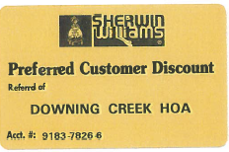
EXHIBIT C – Sherwin Williams Discount
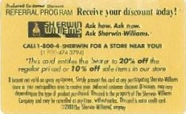
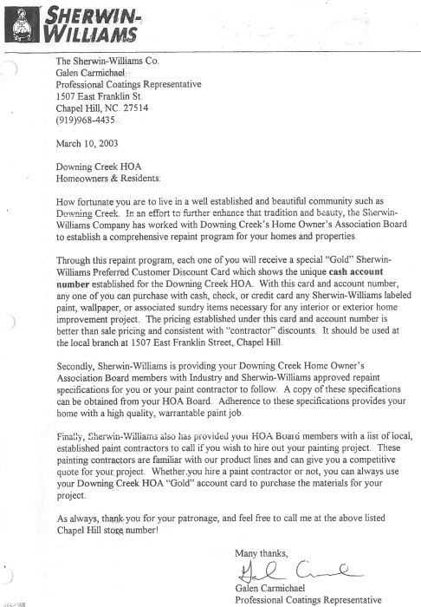
Instructions:
Applicants should review the DCCA Architectural Guidelines in detail and be aware of all DCCA requirements for exterior improvement submittals.
Please complete the appropriate section(s) below and attach any supporting sketches, plans, photos or other documentation, including plots plans, elevations, dimensions, samples and finishes or other items as may be needed to describe the details and dimensions of the proposed modifications.
Note: Incomplete applications, those with insufficient detail, improper format, or without all necessary information will not be considered.
Homeowner can scan and submit a signed electronic copy of the AMA application to cam@downingcreek.org or make three (3) hard copies of the signed application and documentation and deliver them to the DCCA pool drop box.
The DCCA Community Association Manager (CAM) will acknowledge and log the date of a complete AMA request. The CAM and will distribute the AMA request to members of the AAC and DCCA BOD electronically.
Be advised, if you proceed with your proposed work prior to obtaining DCCA BOD approval, you could be required to make changes to work at your expense.
As a courtesy, please advise your neighbors who may reasonably view the improvement from their property of your plans prior to submitting your application to the DCCA CAM.
Name: PLEASE PRINT | Email:
Property Address: | Telephone
Signature | Date
Contractor Name (if applicable) | Contractor Phone Number(if applicable)
Project Type | Check as appropriate
Painting | Roof | Deck/Patio | Fence | Addition | Other
Painting Exteriors
Provide the manufacturer color names and numbers for all even if same as existing.
Base House Color: | Trim Color: | Shutter Color: | Door Color(if applicable)
SAME As Existing_________ | SAME As Existing_________ | SAME As Existing_________ | SAME As Existing_________
All Projects (e.g. Decks, Patios, Fences, Additions, or any Other type)
Please describe proposed modification and provide all supporting information (sketches, plans, samples or other documentation) applicable to visualize and review the request. Note: Incomplete applications, those with insufficient detail, improper format or without all necessary information will not be considered. Use a separate sheet of paper if needed.
- A site plan or plat showing the proposed location of the improvement in relationship to the house, any existing structures and property lines along with dimensions.
- A sketch or diagram, illustrating layout, floor plan, and elevations (front and profile views) with details of the improvement. These should be drawn to scale with sufficient detail, including dimensions so DCCA BOD can adequately visualize the proposed scope of work.
- Detailed specifications, descriptions and samples of materials, color, manufacturer brochures, photos, etc. Note: DCCA BOD may request and require actual material or color samples depending type of improvement.
- For fences, additions or other structures, please identify and mark surveyor pins and lot line locations with flags or stakes for easy reference.

DCCA AMA Page 2

Project Description
Roof Replacement
Provide Asphalt Shingle Manufacturer, Grade, Style & Color
“I acknowledge that I have read a copy of the DCCA Association Architectural Guidelines.
I understand If this architectural change is approved by DCCA BOD, I agree to complete the scope as submitted and to meet any and all codes, permits or other requirements deemed necessary by county, state or other applicable authority. Approval by DCCA BOD does not constitute approval as to compliance with applicable North Carolina law or Durham City-County ordinances.
I do understand that it will be my responsibility to complete work as approved and that I will be responsible for repairs of any damage this change causes to adjacent properties or utilities.
I understand any change to the scope of work, including changing color from what was originally approved by DCCA BOD- will require an updated AMA request and obtain additional approval for the scope change.”
Property/Homeowner signature |  | Date
DCCA Board Action
AMA Acknowledge Date by CAM | Approval |  | Conditional Approval |  | Disapproval
DCCA BOD Signatures |  |  |  | Date:

